

**American International University, Bangladesh**

Faculty of Science and Technology

**Introduction to Database** Section: F

Group: 1

**Project Name:** GADGET And GEAR MANAGEMENT SYSTEM

**Instructor : SIFAT RAHMAN AHONA**

**Group Members:**

|  |  |
| --- | --- |
| **Name** | **ID** |
| **ENAMUL HAQUE ALVI** | **23-51417-1** |

**INDEX**

|  |  |  |
| --- | --- | --- |
| **SERIAL NO.** | **CONTEXT** | **PAGE NO.** |
| **01** | **Describe** | **03** |
| **02** | **Scenario** | **04-05** |
| **03** | **ER Diagram** | **06** |
| **04** | **Normalization** | **07-14** |
| **05** | **Table Creation , Data Insertion** | **15-40** |
| **06** | **Query Test in DB** | **41-49** |
| **07** | **Conclusion** | **49-53** |

**Describe**

A **gadget and gear shop management system** is a comprehensive solution designed to efficiently organize and track electronic devices, accessories, and equipment. These systems utilize smart technology, such as RFID tags or digital platforms, to keep tabs on your gear. Whether you’re a professional photographer managing camera equipment or an everyday user keeping track of your gadgets, these systems ensure that everything is accounted for, easily accessible, and well-organized. From inventory management to secure storage, they streamline the process of handling and maintaining your valuable gear.

**Scenario**

In a Gadget and Gear  Shop Management System, this shop has many branches and every branch has unique BranchID ,Loaction,Opening&Closing Time,Close Date .The manager has own unique ManagerID,Manager Name,Phone Number,Duty Time,Salary. One branch is include by only one manager. There are many salesman in one branch and all the salesman manage by the branch manager . A salesman may sales many gadget. To identify a salesman the system stores salesman ID, salesman name, salesman phone along with salesman  email,salary,duty time. Salesman of the shop maintain gadget details of the stock. The customer with their properties unique customer's id, name, phone, address, and mail and they can check the items available in the stock and select the product of their choice. A customer is permitted to check more than one gadget item at a time, and an available item also can be checked by more than one customer. The gadget items have some characteristics, such as item unique ProductID, P.Name, price and category. Customers may keep adding one or more items to the cart until the end of the product selection cycle. An item may not be added to a particular customer's cart more than once but a particular cart could have more items. The cart can have properties like cart id, offers,discount and total cost depending on items. After adding all the desired products to the cart, it is up to the customer to confirm the order or not. If the customers would like to buy  an items added to the cart, the items on the cart go once to order details with their confirmation. A customer has the right to confirm multiple orders at the same time, but a specific order in the order details by its properties order id, subtotal cost depending on the cart, shipping cost, total payable amount , delivery date and order date can be confirmed by only one customer. The gadget available in the stock are divided into different categories. Stock is define by product quantity, Current product rate. The stock is fully check by shop . Each category has a name and the unique property of each category is a category number. A category can contain one or more items but a given item can never be in more than one category. There may be multiple types of gadget in stock. A gadget  is sold by a  salesman. There will be an online  buy system. Customers can purchase one or more  gadget from online platform.

**ER Diagram**

Phone Number Number

hone Number

hone Number

**The Shop**

manage

**Cart**

**Order**

Check

**Stock**

Sale

**Customer**Customer

**Manager**

According to

Add Product

Do

Buys

Come from

**Gadget**

**Salesman** 

Include

HAS

**Branch**

Phone Number Number

hone Number

hone Number

Phone Number Number

hone Number

hone Number

**NORMALIZATION**

**HAS** (Branch.ID, Location, Opening&Closing Time, Off Day)

1NF: No Multivalued Attibute

2NF: Branch.ID, Location, Opening&Closing Time, Off Day

3NF: Branch.ID, Location, Opening&Closing Time, Off Day

No Transitive Dependency

Table: Branch.ID, Location, Opening&Closing Time, Off Day

**Check** (Product ID,Product Quantity, Current Product Rate)

1NF: No Multivalued Attribute

2NF: Product ID, Product Quantity, Current Product Rate

3NF: Product ID ,Product Quantity, Current Product Rate

No Transitive Dependency

Table: Product ID, Product Quantity, Current Product Rate

**Include** (Branch.ID, Location, Opening&Closing Time, Off Day, Manager.ID, M.Name, Phone Number,Salary, Duty Time)

1NF: Phone Number Multivalued Attribute

2NF: Branch.ID, Location, Opening&Closing Time, Off Day, Manager.ID

Manager.ID, M.Name, Phone Number, Salary, Duty Time

3NF: Branch.ID, Location, Opening&Closing Time, Off Day, Manager.ID

Manager.ID, M.Name, Phone Number, Salary, Duty Time

No Transitive Dependency

Table: Branch.ID, Location, Opening&Closing Time, Off Day, Manager.ID

Manager.ID, M.Name, Phone Number, Salary, Duty Time

**Manage** (Manager.ID, M.Name, Phone Number, Salary, Duty Time, Salesman.ID, Name, Phone Number, Salary, Duty Time, E-mail)

1NF: Phone Number Multivalued Attribute

2NF: Manager.ID, M.Name, Phone Number, Salary, Duty Time

Salesman.ID, Name, Phone Number, Salary, Duty Time, E-mail, Manager.ID

3NF: Manager.ID, M.Name, Phone Number, Salary, Duty Time

Salesman.ID, Name, Phone Number, Salary, Duty Time, E-mail, Manager.ID

No Transitive Dependency

Table: Manager.ID, M.Name, Phone Number, Salary, Duty Time

Salesman.ID, Name, Phone Number, Salary, Duty Time, E-mail, Manager.ID

**Sale** (Salesman.ID, Name, Phone Number, Salary, Duty Time, E-mail, Customer.ID, Phone Number, C.Name, Address, E-mail)

1NF: Phone Number Multivalued Attribute

2NF: Salesman.ID, Name, Phone Number, Salary, Duty Time, E-mail

Customer.ID, Phone Number, C.Name, Address, E-mail, Salesman.ID

3NF: Salesman.ID, Name, Phone Number, Salary, Duty Time, E-mail

Customer.ID, Phone Number, C.Name, Address, E-mail, Salesman.ID

No Transitive Dependency

Table: Salesman.ID, Name, Phone Number, Salary, Duty Time, E-mail

Customer.ID, Phone Number, C.Name, Address, E-mail, Salesman.ID

**Buys** (Customer.ID, Phone Number, C.Name, Address, E-mail, Gadegt.ID, G.Name, Price, Category)

1NF: Phone Number Multivalued Attribute

2NF: Customer.ID, Phone Number, C.Name, Address, E-mail

Gadegt.ID, G.Name, Price, Category

CGID, Customer.ID, Gadegt.ID

3NF: Customer.ID, Phone Number, C.Name, Address, E-mail

Gadegt.ID, G.Name, Price, Category

CGID, Customer.ID, Gadegt.ID

No Transitive Dependency

Table: Customer.ID, Phone Number, C.Name, Address, E-mail

Gadegt.ID, G.Name, Price, Category

CGID, Customer.ID, Gadegt.ID

**Come From** (Product ID ,Product Quantity, Current Product Rate, Gadegt.ID, G.Name, Price, Category)

1NF: No Multivalued Attribute

2NF: Product ID ,Product Quantity, Current Product Rate

Gadegt.ID, G.Name, Price, Category,Product ID

3NF: Product ID ,Product Quantity, Current Product Rate

Gadegt.ID, G.Name, Price, Category, Product ID

No Transitive Dependency

Table: Product ID ,Product Quantity, Current Product Rate

Gadegt.ID, G.Name, Price, Category, Product ID

**Add Product** (Customer.ID, Phone Number, C.Name, Address, E-mail, Chart.ID, Total Cost, Offers, Discount)

1NF: Phone Number Multivalued Attribute

2NF: Customer.ID, Phone Number, C.Name, Address, E-mail

Chart.ID, Total Cost, Offers, Discount, Customer.ID

3NF: Customer.ID, Phone Number, C.Name, Address, E-mail

Chart.ID, Total Cost, Offers, Discount, Customer.ID

No Transitive Dependency

Table: Customer.ID, Phone Number, C.Name, Address, E-mail

Chart.ID, Total Cost, Offers, Discount, Customer.ID

**Do** (Customer.ID, Phone Number, C.Name, Address, E-mail, Order.ID, Delivery Date,Total Pay, Sub total cost, Order Date, Shipping Cost)

1NF: Phone Number Multivalued Attribute

2NF: Customer.ID, Phone Number, C.Name, Address, E-mail

Order.ID, Delivery Date,Total Pay, Sub total cost, Order Date, Shipping Cost

COID, Customer.ID, Order.ID

3NF: Customer.ID, Phone Number, C.Name, Address, E-mail

Order.ID, Delivery Date , Order Date, Total Cost

COID, Customer.ID, Order.ID

Total Cost ,Total Pay, Sub total cost, Shipping Cost

Table: Customer.ID, Phone Number, C.Name, Address, E-mail

Order.ID, Delivery Date , Order Date, Tot.al Cost

COID, Customer.ID, Order.ID

Total Cost ,Total Pay, Sub total cost, Shipping Cost

**According to** (Order.ID, Delivery Date,Total Pay, Sub total cost, Order Date, Shipping Cost, Chart.ID, Total Cost, Offers, Discount)

1NF: No Mutivalued Attibute

2NF: Order.ID, Delivery Date,Total Pay, Sub total cost, Order Date, Shipping Cost

Chart.ID, Total Cost, Offers, Discount, Order.ID

3NF: Order.ID, Delivery Date, Order Date, Total Cost

Chart.ID, Total Cost, Offers, Discount, Order.ID

Total Cost ,Total Pay, Sub total cost, Shipping Cost

Table: Order.ID, Delivery Date, Order Date, Total Cost

Chart.ID, Total Cost, Offers, Discount, Order.ID

Total Cost ,Total Pay, Sub total cost, Shipping Cost

Total Table:

1. Branch.ID, Location, Opening&Closing Time, Off Day
2. Product ID,Product Quantity, Current Product Rate
3. Branch.ID, Location, Opening&Closing Time, Off Day, Manager.ID
4. Manager.ID, M.Name, Phone Number, Salary, Duty Time
5. Manager.ID, M.Name, Phone Number, Salary, Duty Time
6. Salesman.ID, Name, Phone Number, Salary, Duty Time, E-mail, Manager.ID
7. Salesman.ID, Name, Phone Number, Salary, Duty Time, E-mail
8. Customer.ID, Phone Number, C.Name, Address, E-mail, Salesman.ID
9. Customer.ID, Phone Number, C.Name, Address, E-mail
10. Gadegt.ID, G.Name, Price, Category
11. CGID, Customer.ID, Gadegt.ID
12. Product ID,Product Quantity, Current Product Rate
13. Gadegt.ID, G.Name, Price, Category
14. Customer.ID, Phone Number, C.Name, Address, E-mail
15. Chart.ID, Total Cost, Offers, Discount, Customer.ID
16. Customer.ID, Phone Number, C.Name, Address, E-mail
17. Order.ID, Delivery Date,Order Date,Total Cost
18. COID, Customer.ID, Order.ID
19. Total Cost ,Total Pay, Sub total cost, Shipping Cost
20. Order.ID, Delivery Date, Order Date, Total Cost
21. Chart.ID, Total Cost, Offers, Discount, Order.ID

Final Table:

1. Product ID,Product Quantity, Current Product Rate
2. Branch.ID, Location, Opening&Closing Time, Off Day, Manager.ID
3. Manager.ID, M.Name, Phone Number, Salary, Duty Time
4. Salesman.ID, Name, Phone Number, Salary, Duty Time, E-mail, Manager.ID
5. Customer.ID, Phone Number, C.Name, Address, E-mail, Salesman.ID
6. Gadegt.ID, G.Name, Price, Category
7. CGID, Customer.ID, Gadegt.ID
8. Chart.ID, Total Cost, Offers, Discount, Customer.ID
9. Order.ID, Delivery Date, Order Date, Total Cost
10. COID, Customer.ID, Order.ID
11. Chart.ID, Total Cost, Offers, Discount, Order.ID
12. Total Cost ,Total Pay, Sub total cost, Shipping Cost

**Table Creation**

**1.** Product ID,Product Quantity, Current Product Rate

**SQL command :** create table product

(p_id number(10) constraint pro_pid_pk primary key,p_quantity number(10) ,cu_pro_rate number(10))

**Data Insertion :** insert into product (p_id,p_quantity,cu_pro_rate) values (101,10,1000)

insert into product (p_id,p_quantity,cu_pro_rate) values (102,19,2000)

insert into product (p_id,p_quantity,cu_pro_rate) values (103,13,3000)

insert into product (p_id,p_quantity,cu_pro_rate) values (104,18,4000)

insert into product (p_id,p_quantity,cu_pro_rate) values (105,21,5000)

insert into product (p_id,p_quantity,cu_pro_rate) values (106,15,6000)

insert into product (p_id,p_quantity,cu_pro_rate) values (107,11,7000)

insert into product (p_id,p_quantity,cu_pro_rate) values (108,07,8000)

insert into product (p_id,p_quantity,cu_pro_rate) values (109,9,9000)

insert into product (p_id,p_quantity,cu_pro_rate) values (110,12,10000)

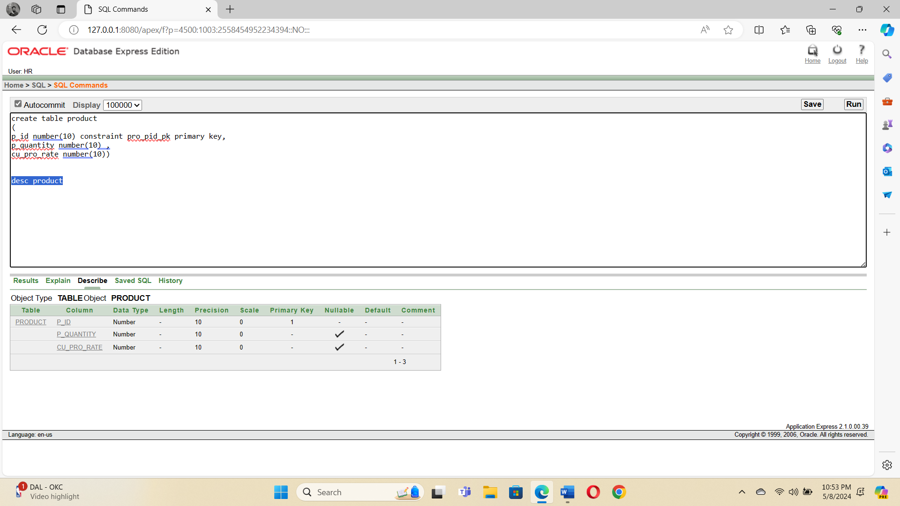

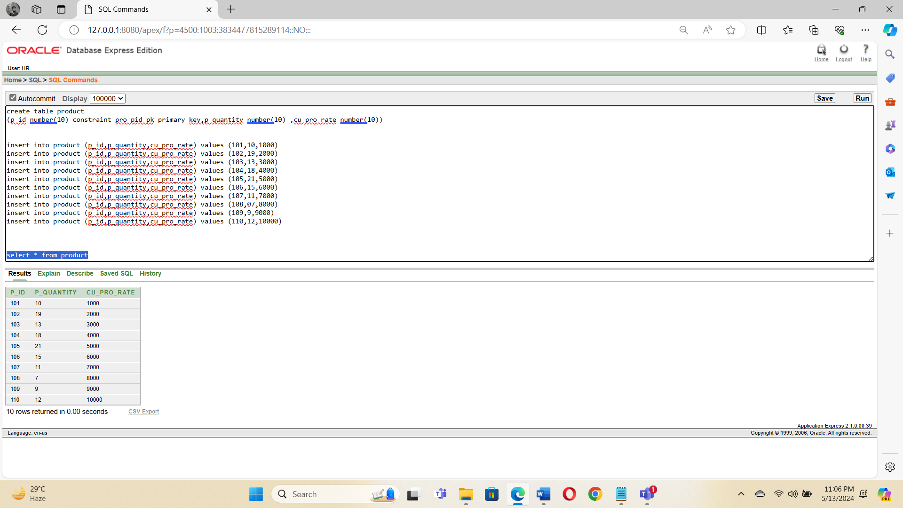

**2.** Branch.ID, Location, Opening&Closing Time, Off Day, Manager.ID

**SQL command :** create table branch

(b_id number(10) constraint bra_bid_pk primary key,op_time varchar2(50),off_day varchar2(50),m_id number(10) references manager(m_id))

**Data Insertion :** insert into branch (b_id,op_time,off_day,m_id) values (1001,'Sun To Fri','Sat',01)

insert into branch (b_id,op_time,off_day,m_id) values (1002,'Mon To Sat','Sun',02)

insert into branch (b_id,op_time,off_day,m_id) values (1003,'Wed To Mon','Tue',03)

insert into branch (b_id,op_time,off_day,m_id) values (1004,'Tue To Sun','Mon',04)

insert into branch (b_id,op_time,off_day,m_id) values (1005,'Sat To Thu','Fri',05)

insert into branch (b_id,op_time,off_day,m_id) values (1006,'Fri To Wed','Thu',06)

insert into branch (b_id,op_time,off_day,m_id) values (1007,'Thu To Tue','Wed',07)

insert into branch (b_id,op_time,off_day,m_id) values (1008,'Sun To Fri','Sat',08)

insert into branch (b_id,op_time,off_day,m_id) values (1009,'Tue To Sun','Mon',09)

insert into branch (b_id,op_time,off_day,m_id) values (1010,'Sat To Thu','Fri',10)

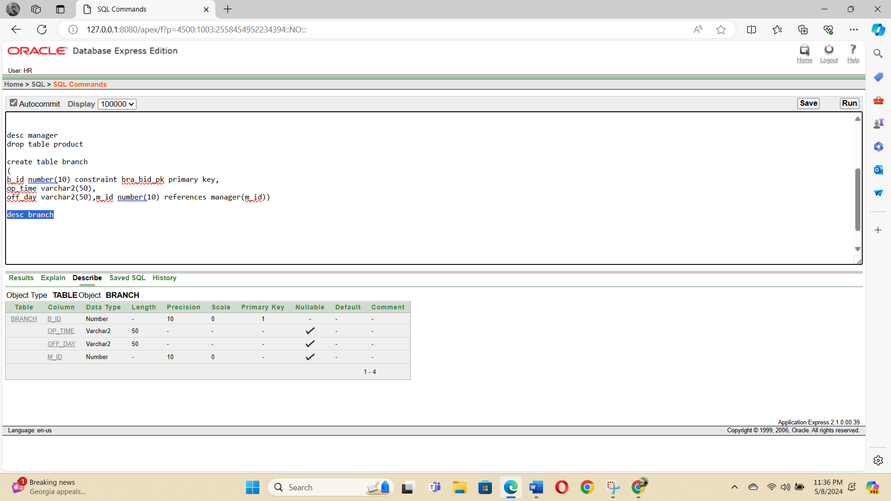

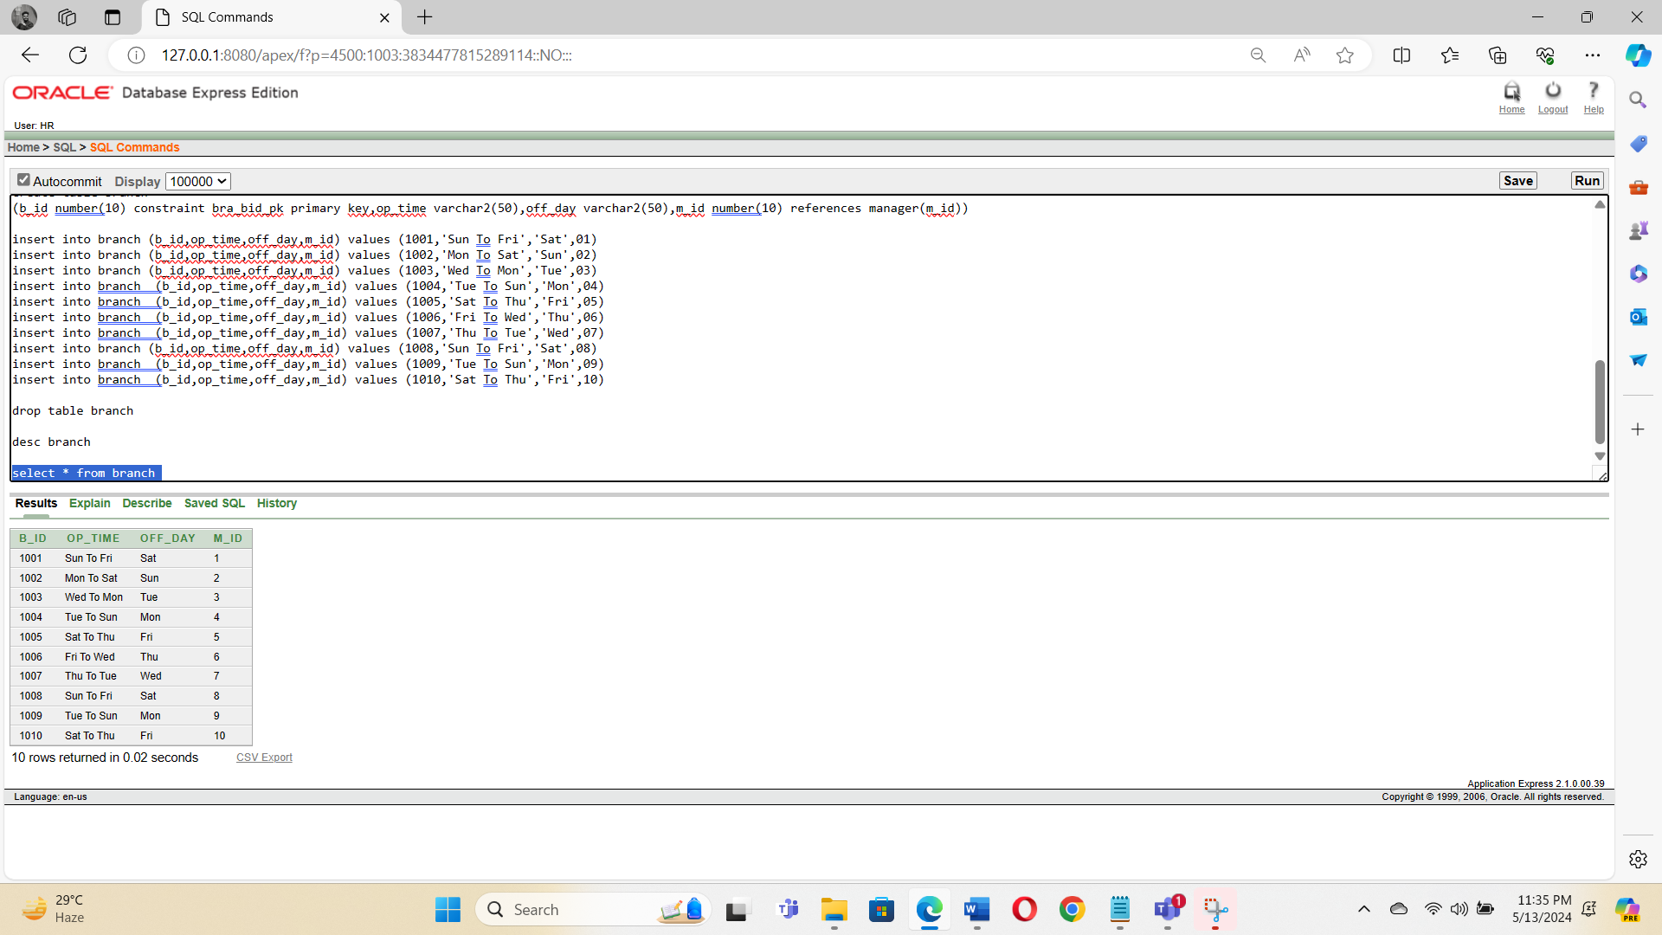

**3.** Manager.ID, M.Name, Phone Number, Salary, Duty Time

**SQL command :** create table manager

(m_id number(10) constraint man_mid_pk primary key,m_name varchar2(50),phone_number number(11),salary number(10),duty_time varchar2(50))

**Data Insertion :** insert into manager (m_id,m_name,phone_number,salary,duty_time) values (01,'Raz',01700000000,1000,'Sat Mon')

insert into manager (m_id,m_name,phone_number,salary,duty_time) values (02,'Ratul',01700000001,2000,'Sun Tue')

insert into manager (m_id,m_name,phone_number,salary,duty_time) values (03,'Paul',01700000002,3000,'Mon Wed')

insert into manager (m_id,m_name,phone_number,salary,duty_time) values (04,'Sabab',01700000003,4000,'Fri Thu')

insert into manager (m_id,m_name,phone_number,salary,duty_time) values (05,'Rezone',01700000004,5000,'Mon Wed')

insert into manager (m_id,m_name,phone_number,salary,duty_time) values (06,'Pritom',01700000005,6000,'Mon Wed')

insert into manager (m_id,m_name,phone_number,salary,duty_time) values (07,'Alvy',01700000006,7000,'Sat Mon')

insert into manager (m_id,m_name,phone_number,salary,duty_time) values (08,'Prantik',01700000007,8000,'Fri Thu')

insert into manager (m_id,m_name,phone_number,salary,duty_time) values (09,'Alex',01700000008,9000,'Sat Mon')

insert into manager (m_id,m_name,phone_number,salary,duty_time) values (10,'Jhon',01700000009,10000,'Sun Tue')

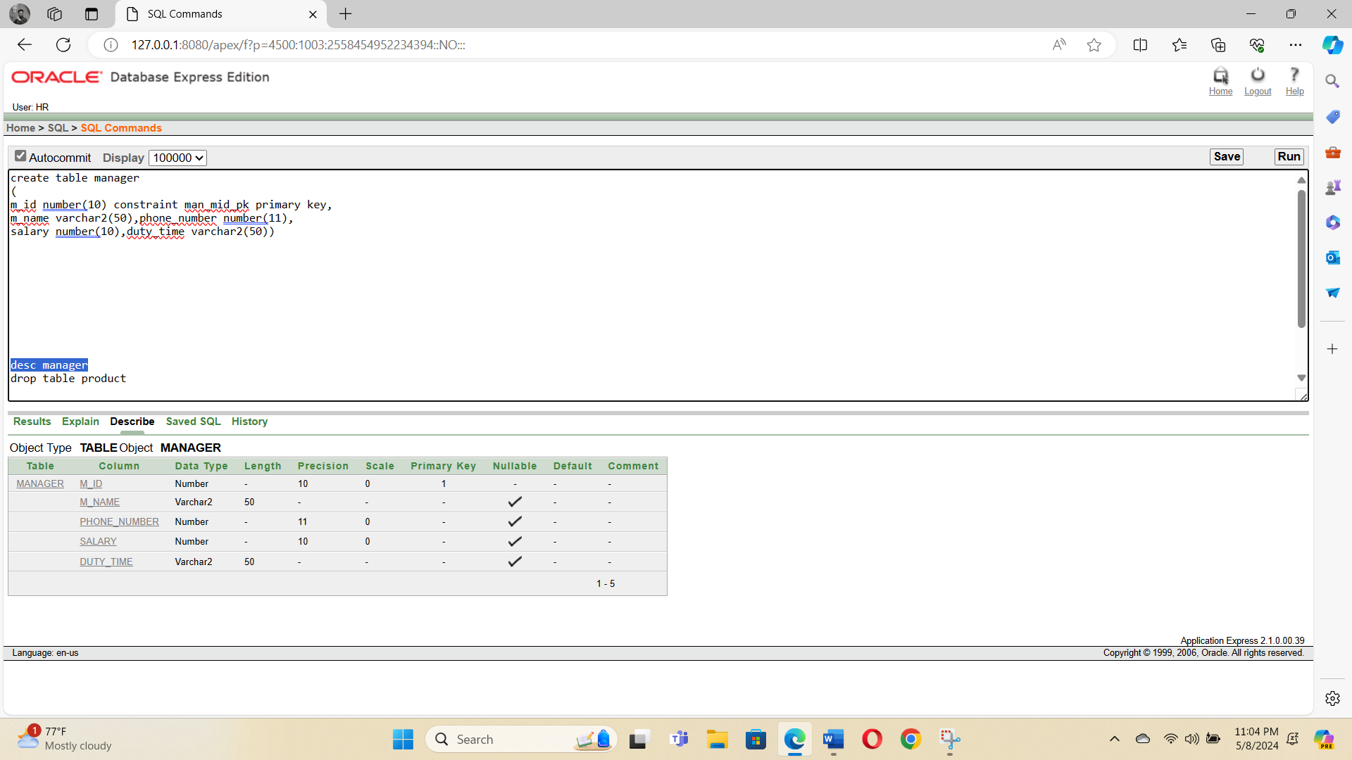

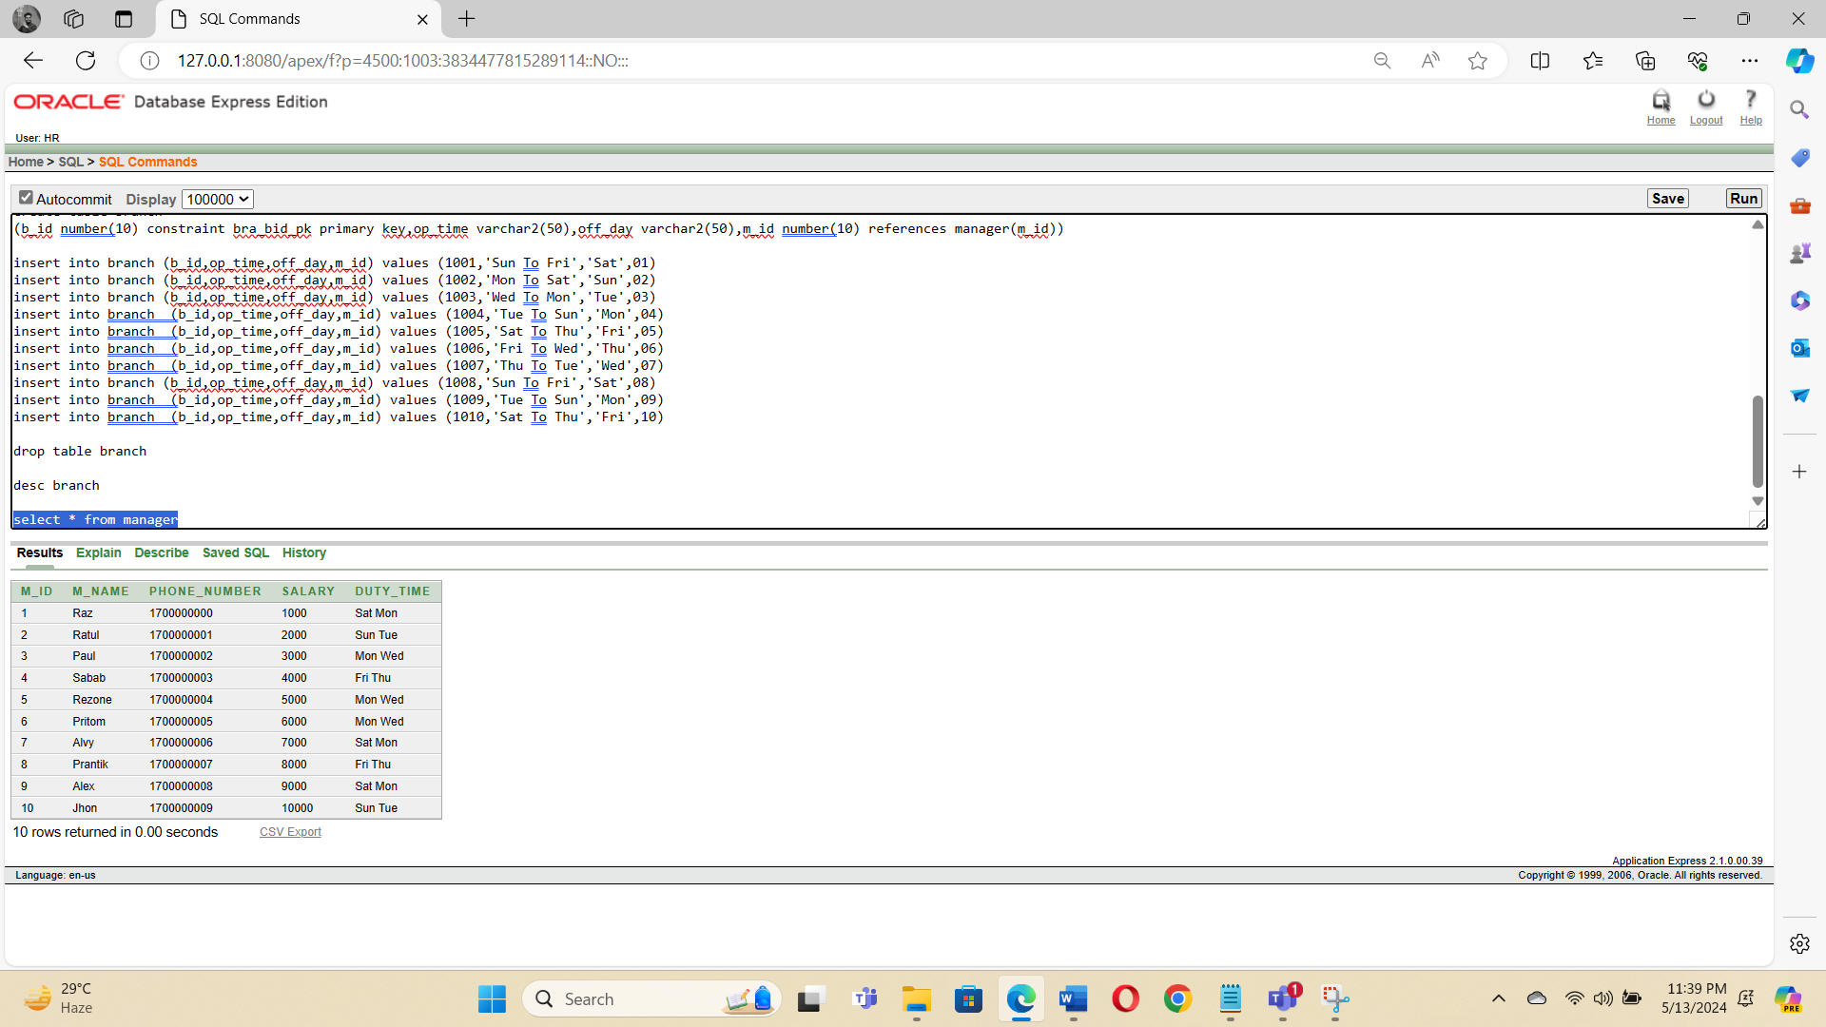

**4.** Salesman.ID, Name, Phone Number, Salary, Duty Time, E-mail, Manager.ID

**SQL command :** create table salesman

(s_id number(10) constraint sel_sid_pk primary key,

phone_number number(11),salary number(10),email varchar2(50),duty_time varchar2(50),m_id number(10) references manager(m_id))

**Data Insertion :** insert into salesman(s_id,phone_number,salary,email,duty_time,m_id) values (2001,01701010111,500,'akij@gmail.com','9am-9pm',01)

insert into salesman(s_id,phone_number,salary,email,duty_time,m_id) values (2002,01701010109,700,'kaji@gmail.com','9am-9pm',02)

insert into salesman(s_id,phone_number,salary,email,duty_time,m_id) values (2003,01701010108,900,'rahim@gmail.com','9am-9pm',03)

insert into salesman(s_id,phone_number,salary,email,duty_time,m_id) values (2004,01701010107,1000,'karim@gmail.com','9am-9pm',04)

insert into salesman(s_id,phone_number,salary,email,duty_time,m_id) values (2005,01701010106,600,'raz@gmail.com','9am-9pm',05)

insert into salesman(s_id,phone_number,salary,email,duty_time,m_id) values (2006,01701010105,800,'ratul@gmail.com','9am-9pm',06)

insert into salesman(s_id,phone_number,salary,email,duty_time,m_id) values (2007,01701010104,700,'paul@gmail.com','9am-9pm',07)

insert into salesman(s_id,phone_number,salary,email,duty_time,m_id) values (2008,01701010103,600,'pritom@gmail.com','9am-9pm',08)

insert into salesman(s_id,phone_number,salary,email,duty_time,m_id) values (2009,01701010102,500,'akbar@gmail.com','9am-9pm',09)

insert into salesman(s_id,phone_number,salary,email,duty_time,m_id) values (2010,01701010101,400,'prantik@gmail.com','9am-9pm',10)

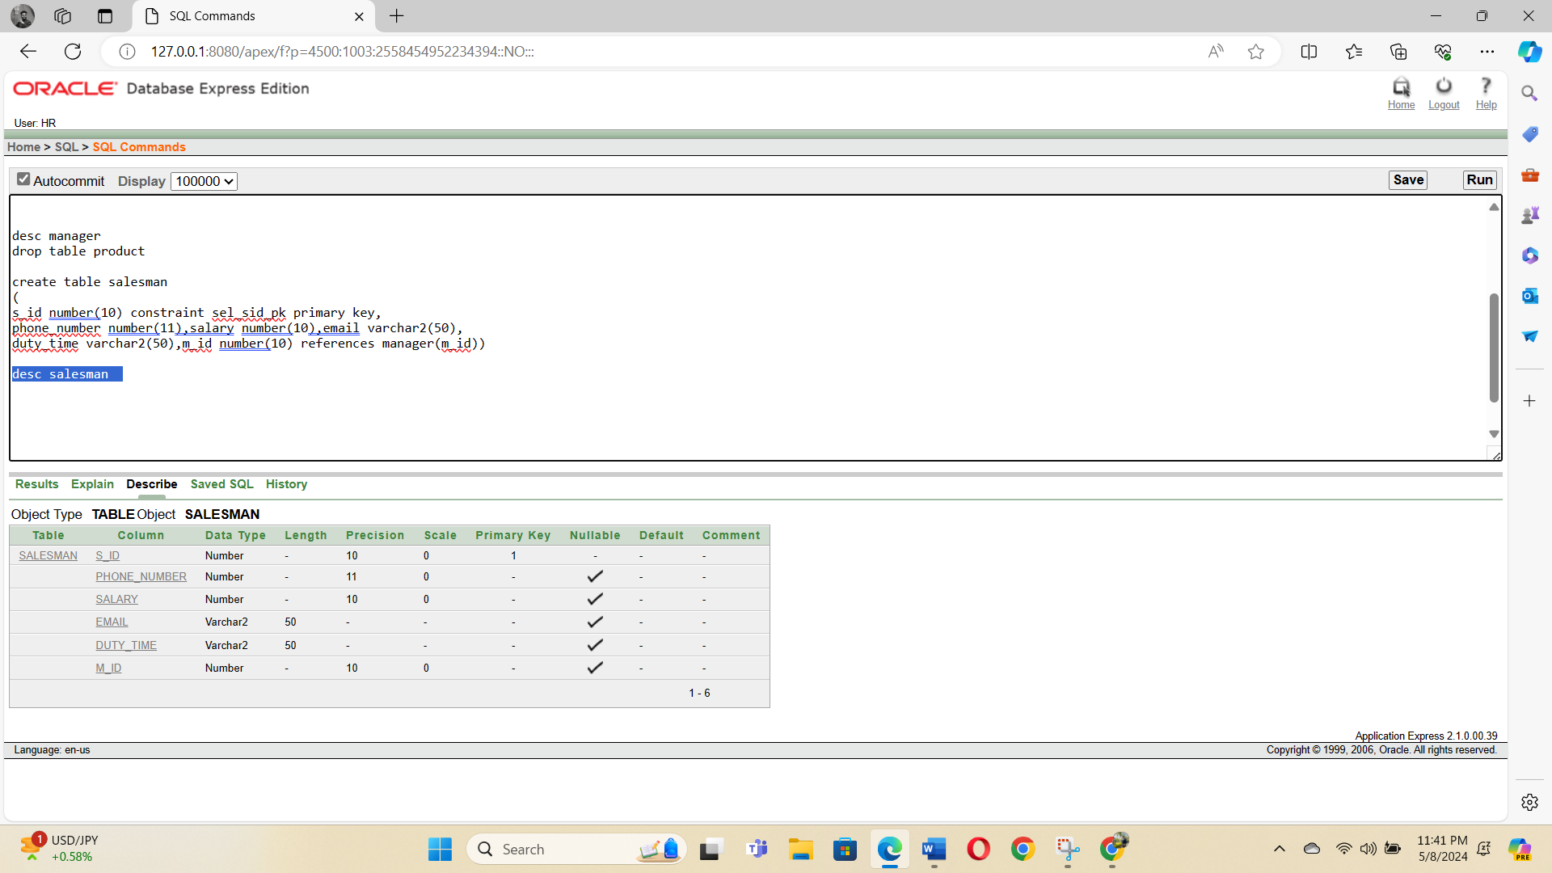

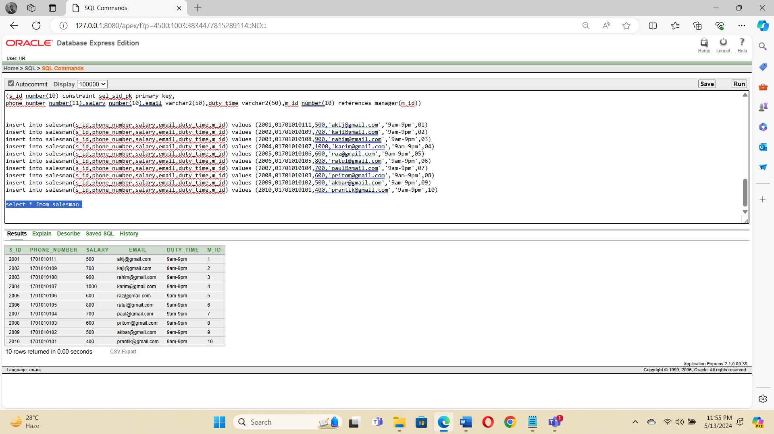

**5.** Customer.ID, Phone Number, C.Name, Address, E-mail, Salesman.ID

**SQL command :** create table customer(c_id number(10) constraint cus_cid_pk primary key,phone_number number(11),c_name varchar2(50),email varchar2(50),s_id number(10) references salesman(s_id))

**Data Insertion :** insert into customer(c_id,phone_number,c_name,email,s_id) values (3001,01701010101,'Akij','akij@gmail.com',2001)

insert into customer(c_id,phone_number,c_name,email,s_id) values (3002,01701010119,'Kaji','kaji@gmail.com',2002)

insert into customer(c_id,phone_number,c_name,email,s_id) values (3003,01701010128,'Rahim','rahim@gmail.com',2003)

insert into customer(c_id,phone_number,c_name,email,s_id) values (3004,01701010137,'Karim','karim@gmail.com',2004)

insert into customer(c_id,phone_number,c_name,email,s_id) values (3005,01701010146,'Raz','raz@gmail.com',2005)

insert into customer(c_id,phone_number,c_name,email,s_id) values (3006,01701010155,'Ratul','ratul@gmail.com',2006)

insert into customer(c_id,phone_number,c_name,email,s_id) values (3007,01701010164,'Paul','paul@gmail.com',2007)

insert into customer(c_id,phone_number,c_name,email,s_id) values (3008,01701010173,'Pritom','pritom@gmail.com',2008)

insert into customer(c_id,phone_number,c_name,email,s_id) values (3009,01701010182,'Akabr','akbar@gmail.com',2009)

insert into customer(c_id,phone_number,c_name,email,s_id) values (3010,01701010191,'Prantik','prantik@gmail.com',2010)

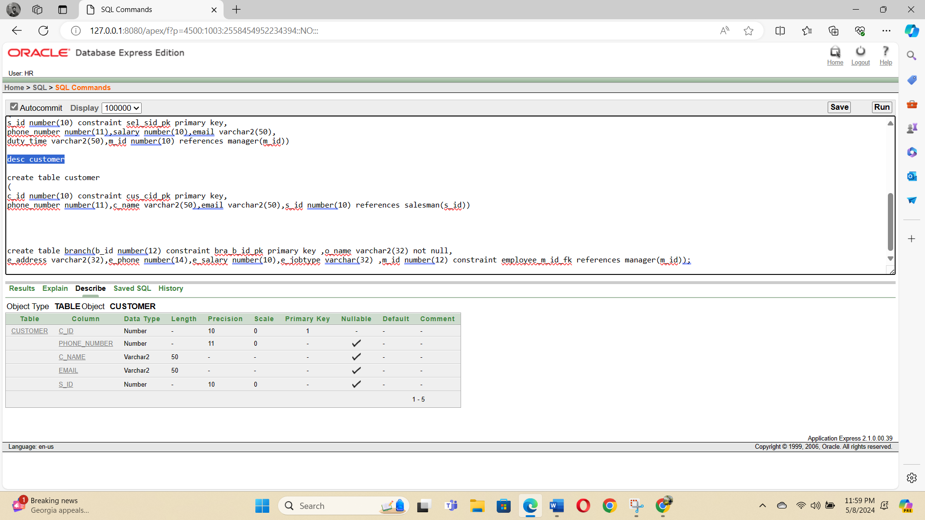

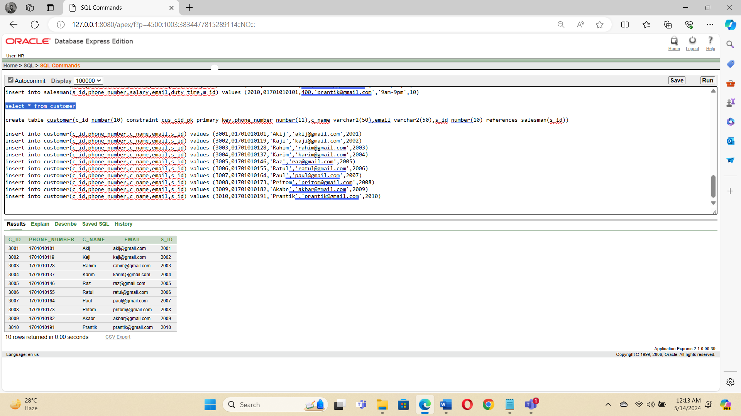

**6.** Gadegt.ID, G.Name, Price, Category

**SQL command :** create table gadget (g_id number(10) constraint gad_gid_pk primary key,g_name varchar2(50),price number(10),category varchar2(50))

**Data Insertion :** insert into gadget(g_id,g_name,price,category) values (5001,'Mouse',300,'Gadget')

insert into gadget(g_id,g_name,price,category) values (5002,'Keyboard',700,'Gadget')

insert into gadget(g_id,g_name,price,category) values (5003,'Calculator',500,'Gadget')

insert into gadget(g_id,g_name,price,category) values (5004,'Sound Box',3000,'Electronic')

insert into gadget(g_id,g_name,price,category) values (5005,'Ear Phone',1000,'Gadget')

insert into gadget(g_id,g_name,price,category) values (5006,'Mobile',50000,'Gadget')

insert into gadget(g_id,g_name,price,category) values (5007,'IPhone',100000,'Gadget')

insert into gadget(g_id,g_name,price,category) values (5008,'Mac Book',150000,'Gadget')

insert into gadget(g_id,g_name,price,category) values (5009,'PC',200000,'Electrical')

insert into gadget(g_id,g_name,price,category) values (5010,'Laptop',75000,'Electrical')

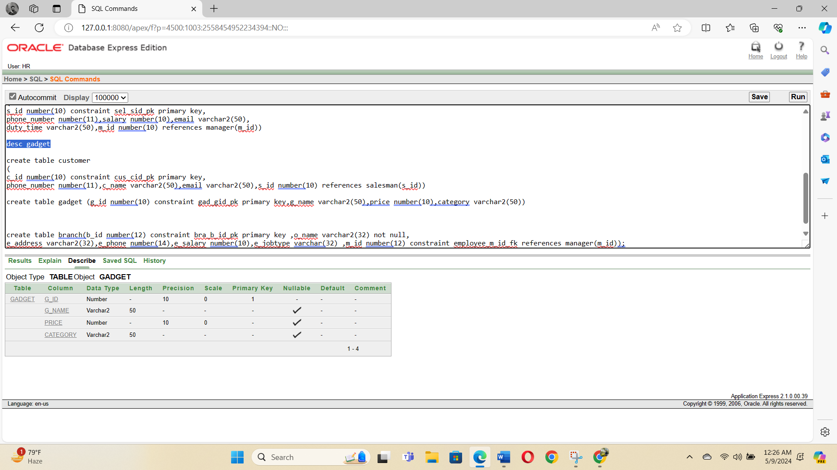

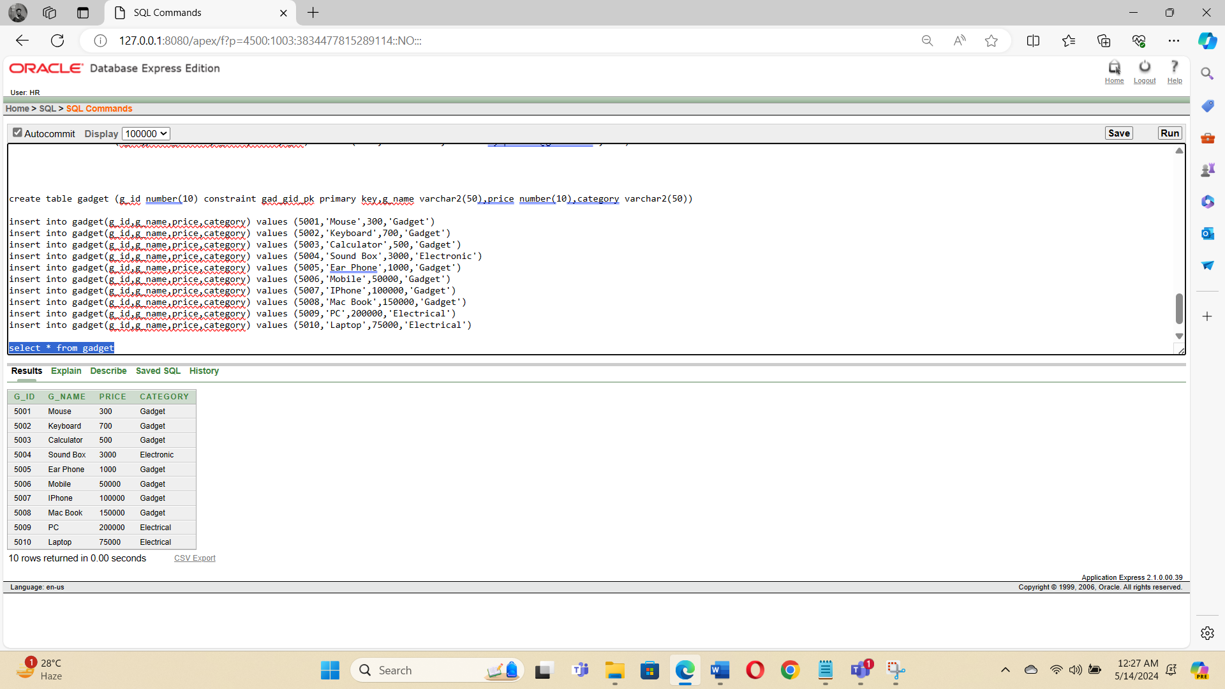

**7.** CGID, Customer.ID, Gadget.ID

**SQL command :** create table CG(cg_id number(10) constraint cg_cgid_pk primary key,c_id number(10) references customer(c_id),g_id number(10) references gadget(g_id))

**Data Insertion :** insert into CG(cg_id,c_id,g_id) values (6001,3001,5001)

insert into CG(cg_id,c_id,g_id) values (6002,3002,5002)

insert into CG(cg_id,c_id,g_id) values (6003,3003,5003)

insert into CG(cg_id,c_id,g_id) values (6004,3004,5004)

insert into CG(cg_id,c_id,g_id) values (6005,3005,5005)

insert into CG(cg_id,c_id,g_id) values (6006,3006,5006)

insert into CG(cg_id,c_id,g_id) values (6007,3007,5007)

insert into CG(cg_id,c_id,g_id) values (6008,3008,5008)

insert into CG(cg_id,c_id,g_id) values (6009,3009,5009)

insert into CG(cg_id,c_id,g_id) values (6010,3010,5010)

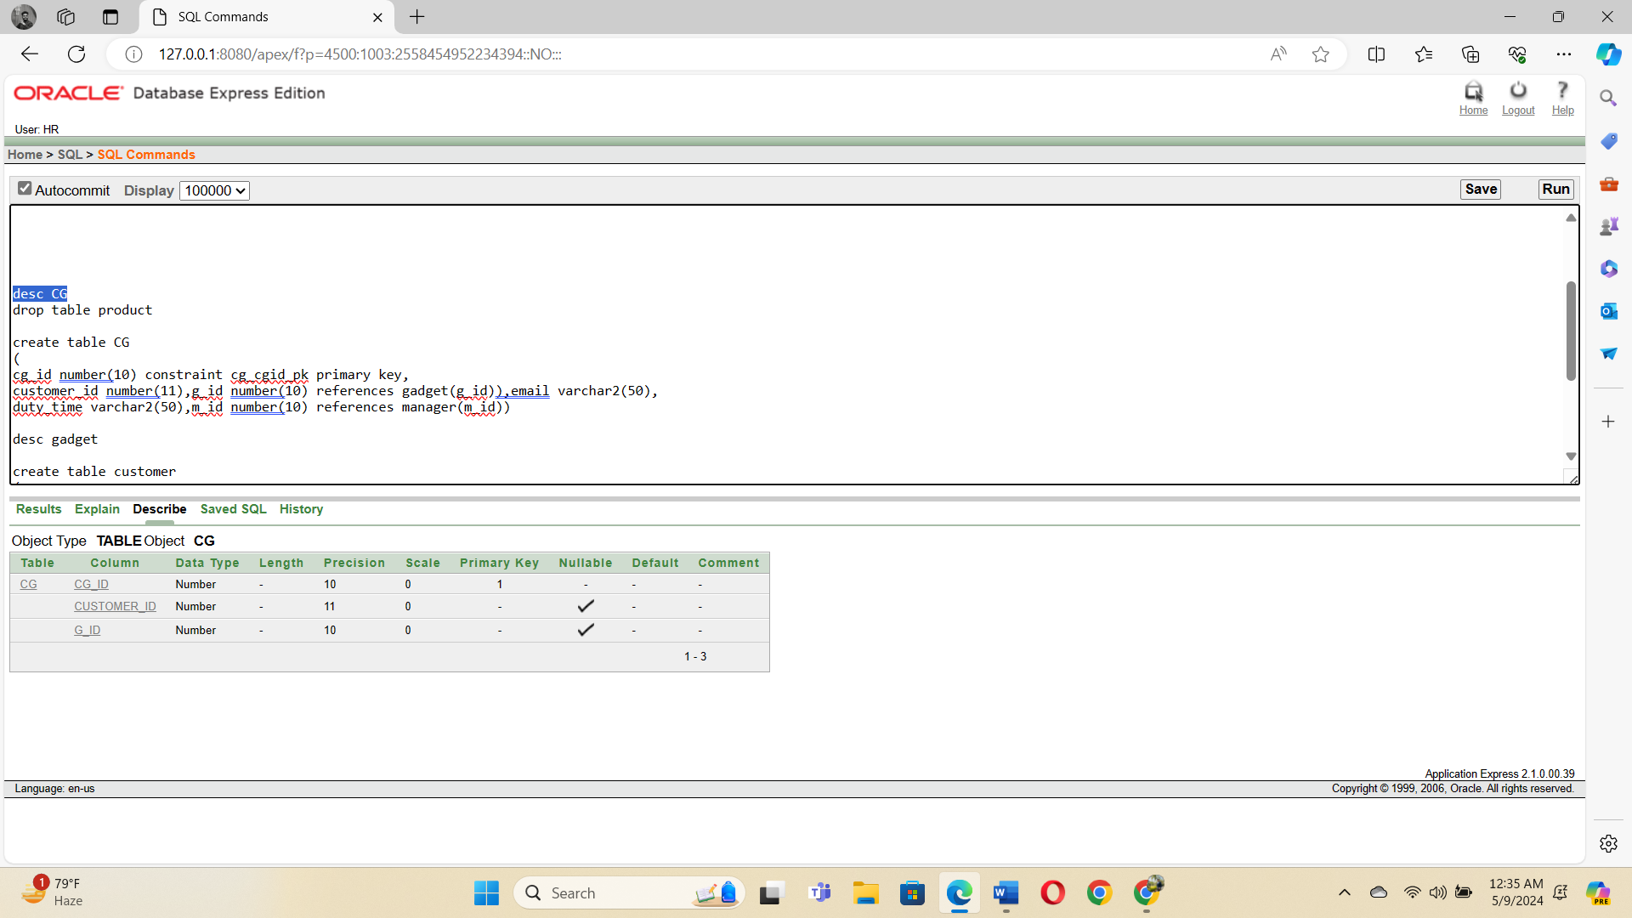

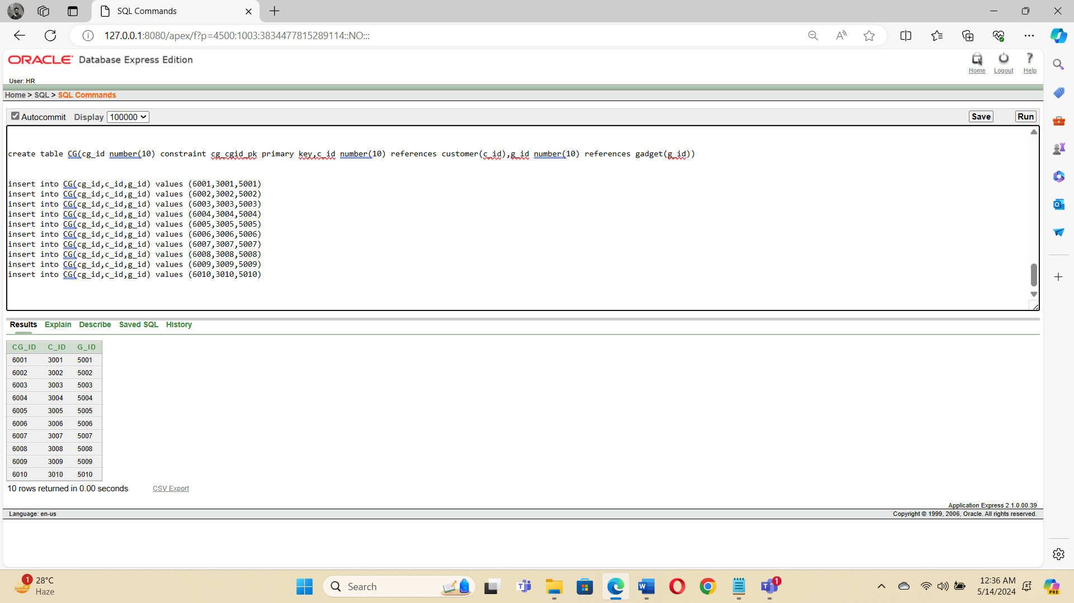

**8.** Chart.ID, Total Cost, Offers, Discount, Customer.ID

**SQL command :** create table cart(cart_id number(10) constraint car_cid_pk primary key,Total_cost number(11),offers varchar2(50),discount number(10),c_id number(10) references customer(c_id))

**Data Insertion :** insert into cart(cart_id,total_cost,offers,discount,c_id) values (7001,1050,'Eid Offer',10,3001)

insert into cart(cart_id,total_cost,offers,discount,c_id) values (7002,2000,'Eid Offer',20,3002)

insert into cart(cart_id,total_cost,offers,discount,c_id) values (7003,1500,'Eid Offer',10,3003)

insert into cart(cart_id,total_cost,offers,discount,c_id) values (7004,1800,'Eid Offer',18,3004)

insert into cart(cart_id,total_cost,offers,discount,c_id) values (7005,20000,'Eid Offer',20,3005)

insert into cart(cart_id,total_cost,offers,discount,c_id) values (7006,10000,'Eid Offer',10,3006)

insert into cart(cart_id,total_cost,offers,discount,c_id) values (7007,6000,'Eid Offer',10,3007)

insert into cart(cart_id,total_cost,offers,discount,c_id) values (7008,50000,'Eid Offer',12,3008)

insert into cart(cart_id,total_cost,offers,discount,c_id) values (7009,10000,'Eid Offer',15,3009)

insert into cart(cart_id,total_cost,offers,discount,c_id) values (7010,8000,'Eid Offer',10,3010)

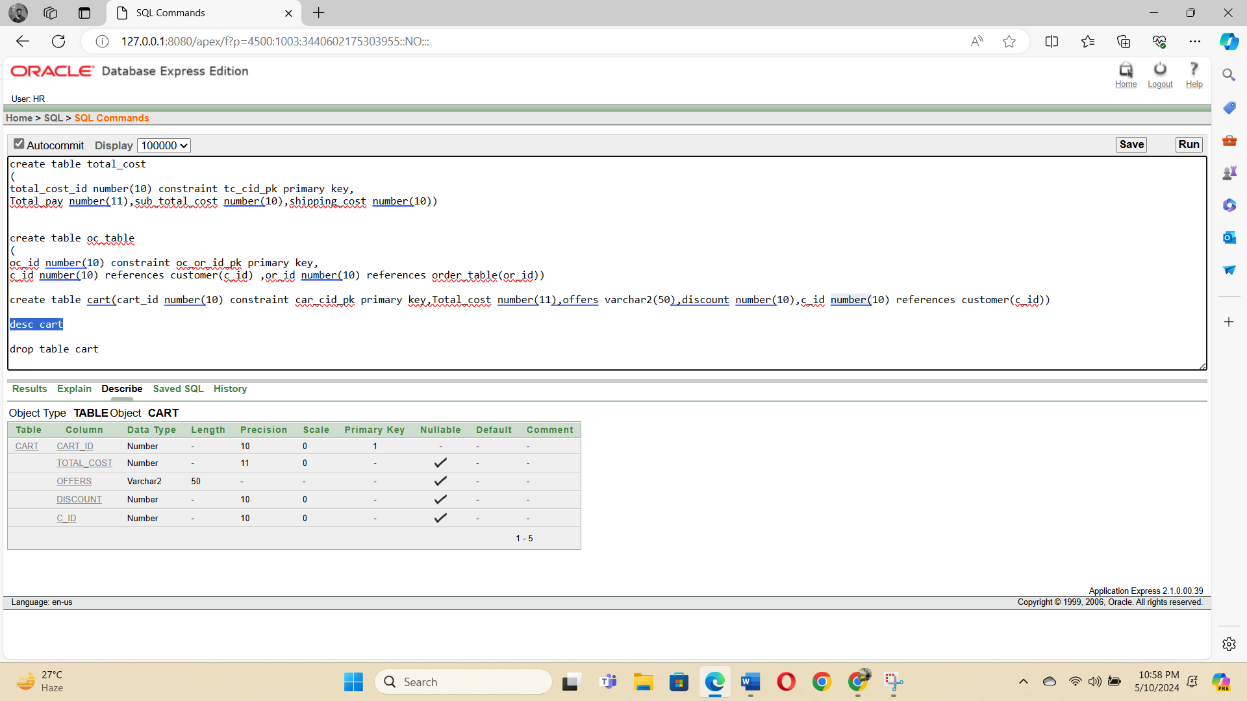

1. Order.ID, Delivery Date, Order Date, Total Cost

**SQL command :**create table order_table(or_id number(10) constraint or_or_id_pk primary key,delivery_date date,order_date date,total_cost number(10) references total_cost(total_cost_id))

**Data Insertion:** insert into order_table(or_id,delivery_date,order_date,total_cost) values (8001,'10-Apr-2024','20-Apr-2024',1050)

insert into order_table(or_id,delivery_date,order_date,total_cost) values (8002,'11-Apr-2024','18-Apr-2024',2000)

insert into order_table(or_id,delivery_date,order_date,total_cost) values (8003,'12-Apr-2024','26-Apr-2024',1500)

insert into order_table(or_id,delivery_date,order_date,total_cost) values (8004,'13-Apr-2024','24-Apr-2024',1800)

insert into order_table(or_id,delivery_date,order_date,total_cost) values (8005,'14-Apr-2024','22-Apr-2024',20000)

insert into order_table(or_id,delivery_date,order_date,total_cost) values (8006,'15-Apr-2024','19-Apr-2024',10000)

insert into order_table(or_id,delivery_date,order_date,total_cost) values (8007,'16-Apr-2024','20-Apr-2024',6000)

insert into order_table(or_id,delivery_date,order_date,total_cost) values (8008,'10-Apr-2024','21-Apr-2024',50000)

insert into order_table(or_id,delivery_date,order_date,total_cost) values (8009,'17-Apr-2024','24-Apr-2024',11000)

insert into order_table(or_id,delivery_date,order_date,total_cost) values (8010,'19-Apr-2024','23-Apr-2024',8000)

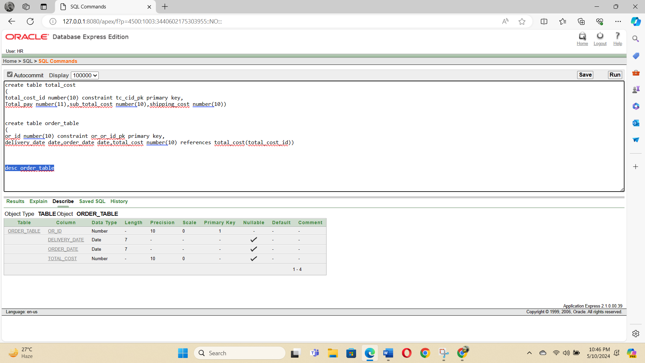

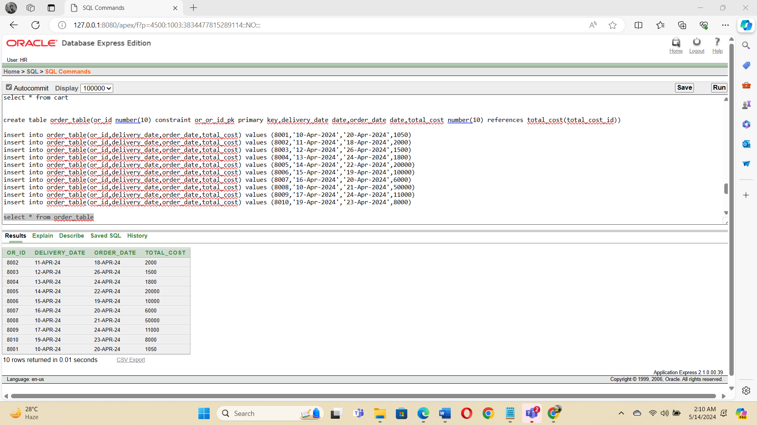

**10 .** COID, Customer.ID, Order.ID

**SQL command :** create table oc_table(oc_id number(10) constraint oc_or_id_pk primary key,c_id number(10) references customer(c_id) ,or_id number(10) references order_table(or_id))

**Data Insertion :** insert into oc_table(oc_id,c_id,or_id) values (9001,3001,8001)

insert into oc_table(oc_id,c_id,or_id) values (9002,3002,8002)

insert into oc_table(oc_id,c_id,or_id) values (9003,3003,8003)

insert into oc_table(oc_id,c_id,or_id) values (9004,3004,8004)

insert into oc_table(oc_id,c_id,or_id) values (9005,3005,8005)

insert into oc_table(oc_id,c_id,or_id) values (9006,3006,8006)

insert into oc_table(oc_id,c_id,or_id) values (9007,3007,8007)

insert into oc_table(oc_id,c_id,or_id) values (9008,3008,8008)

insert into oc_table(oc_id,c_id,or_id) values (9009,3009,8009)

insert into oc_table(oc_id,c_id,or_id) values (9010,3010,8010)

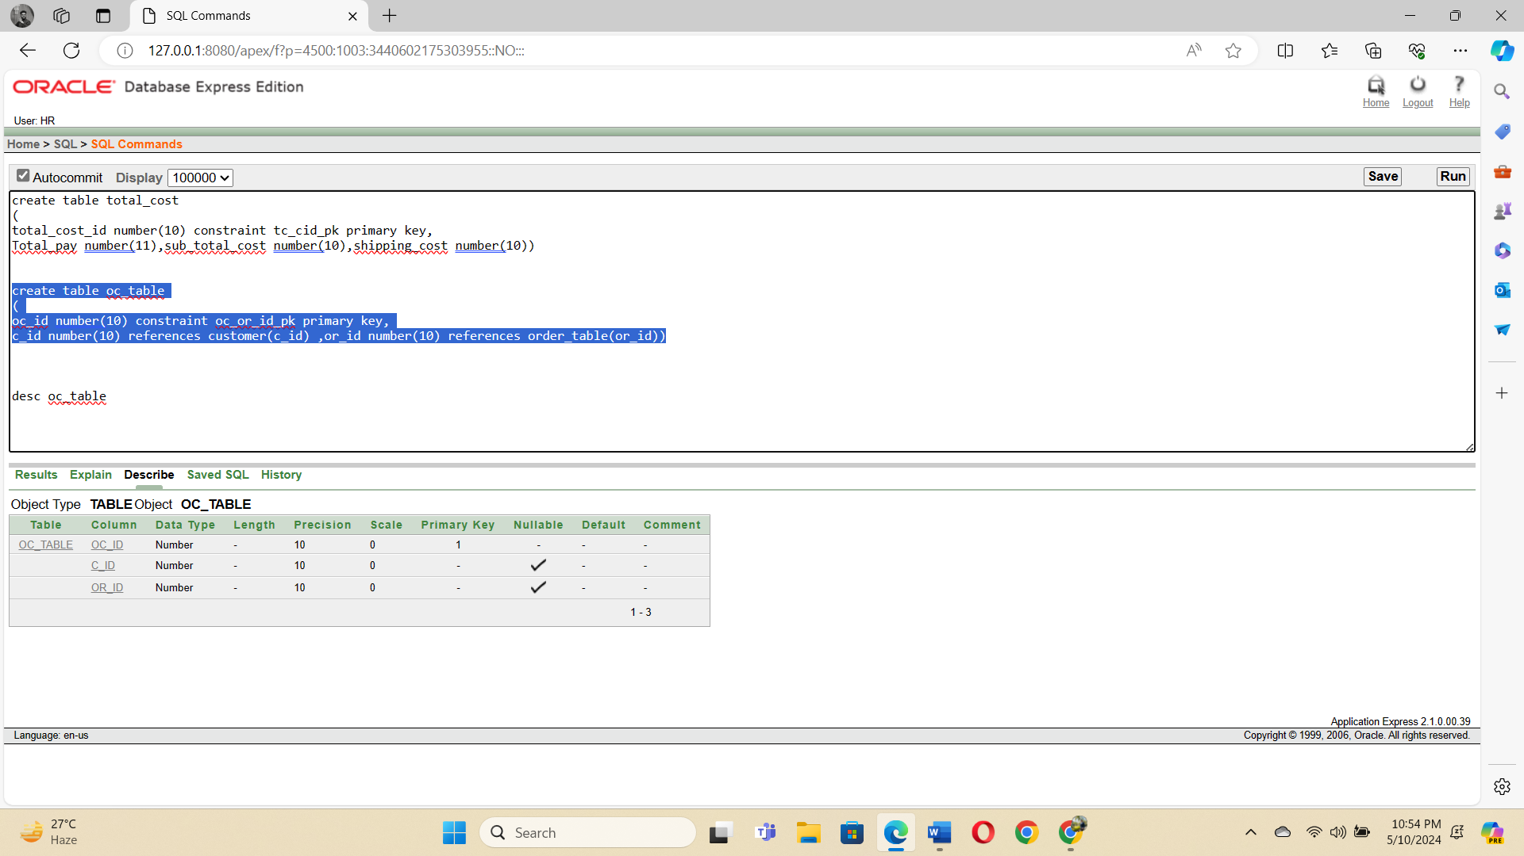

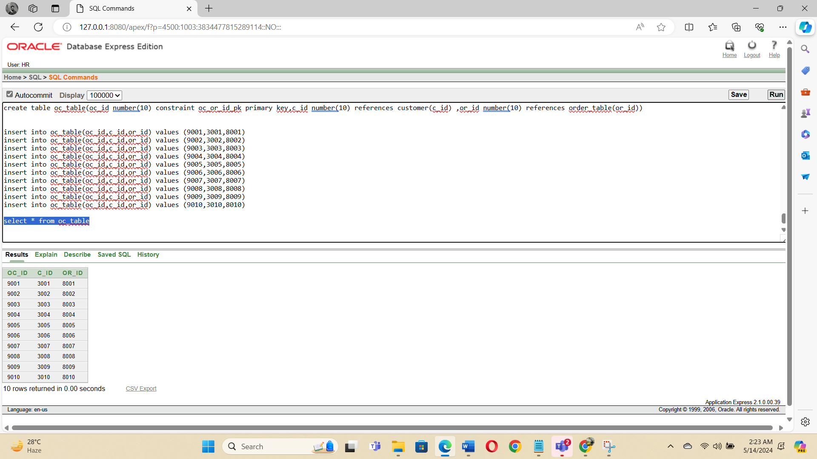

**11 .** Chart.ID, Total Cost, Offers, Discount, Order.ID

**SQL command :** create table cart_table(cart_id number(10) constraint cart_cid_pk primary key,Total_cost number(11),offers varchar2(50),discount number(10),or_id number(10) references order_table(or_id))

**Data Insertion :** insert into cart_table(cart_id,total_cost,offers,discount,or_id) values (7001,1050,'Eid Offer',10,8001)

insert into cart_table(cart_id,total_cost,offers,discount,or_id) values (7002,2000,'Eid Offer',20,8002)

insert into cart_table(cart_id,total_cost,offers,discount,or_id) values (7003,1500,'Eid Offer',10,8003)

insert into cart_table(cart_id,total_cost,offers,discount,or_id) values (7004,1800,'Eid Offer',18,8004)

insert into cart_table(cart_id,total_cost,offers,discount,or_id) values (7005,20000,'Eid Offer',20,8005)

insert into cart_table(cart_id,total_cost,offers,discount,or_id) values (7006,10000,'Eid Offer',10,8006)

insert into cart_table(cart_id,total_cost,offers,discount,or_id) values (7007,6000,'Eid Offer',10,8007)

insert into cart_table(cart_id,total_cost,offers,discount,or_id) values (7008,50000,'Eid Offer',12,8008)

insert into cart_table(cart_id,total_cost,offers,discount,or_id) values (7009,10000,'Eid Offer',15,8009)

insert into cart_table(cart_id,total_cost,offers,discount,or_id) values (7010,8000,'Eid Offer',10,8010)

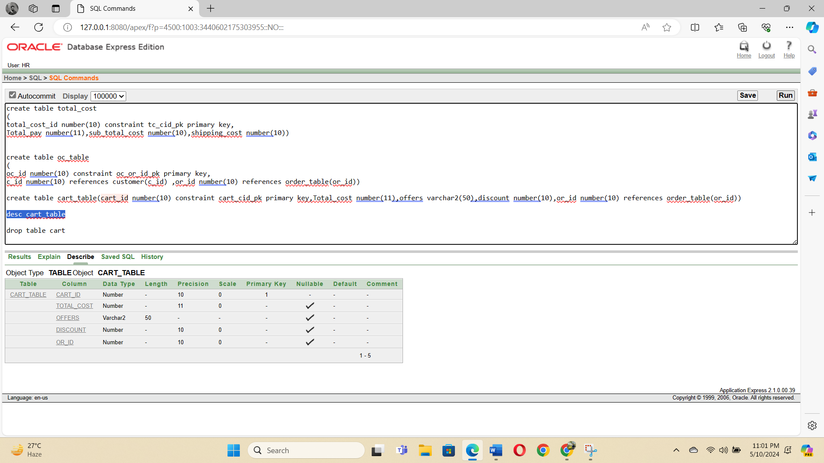

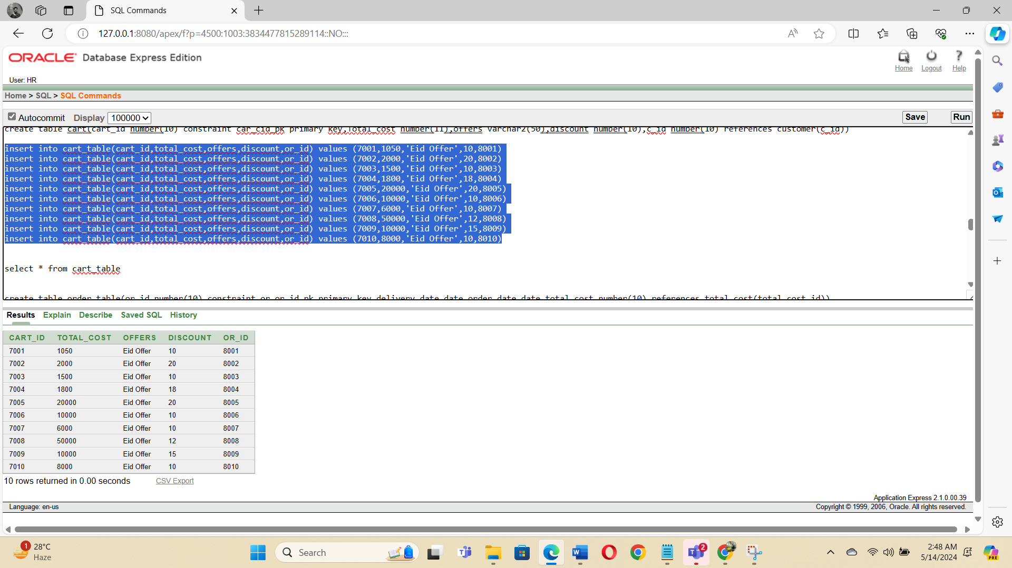

1. Total Cost ,Total Pay, Sub total cost, Shipping Cost

**SQL command :** create table total_cost(total_cost_id number(10) constraint tc_cid_pk primary key,Total_pay number(11),sub_total_costnumber(10),shipping_cost number(10))

**Data Insertion :** insert into total_cost(total_cost_id,total_pay,sub_total_cost,shipping_cost) values (1050,1050,1000,50)

insert into total_cost(total_cost_id,total_pay,sub_total_cost,shipping_cost) values (2000,2000,1900,100)

insert into total_cost(total_cost_id,total_pay,sub_total_cost,shipping_cost) values (1500,1500,1475,25)

insert into total_cost(total_cost_id,total_pay,sub_total_cost,shipping_cost) values (1800,1800,1700,100)

insert into total_cost(total_cost_id,total_pay,sub_total_cost,shipping_cost) values (20000,20000,19850,150)

insert into total_cost(total_cost_id,total_pay,sub_total_cost,shipping_cost) values (10000,10000,9940,60)

insert into total_cost(total_cost_id,total_pay,sub_total_cost,shipping_cost) values (6000,6000,5800,200)

insert into total_cost(total_cost_id,total_pay,sub_total_cost,shipping_cost) values (50000,50000,49890,110)

insert into total_cost(total_cost_id,total_pay,sub_total_cost,shipping_cost) values (11000,11000,10900,100)

insert into total_cost(total_cost_id,total_pay,sub_total_cost,shipping_cost) values (8000,8000,7800,200)

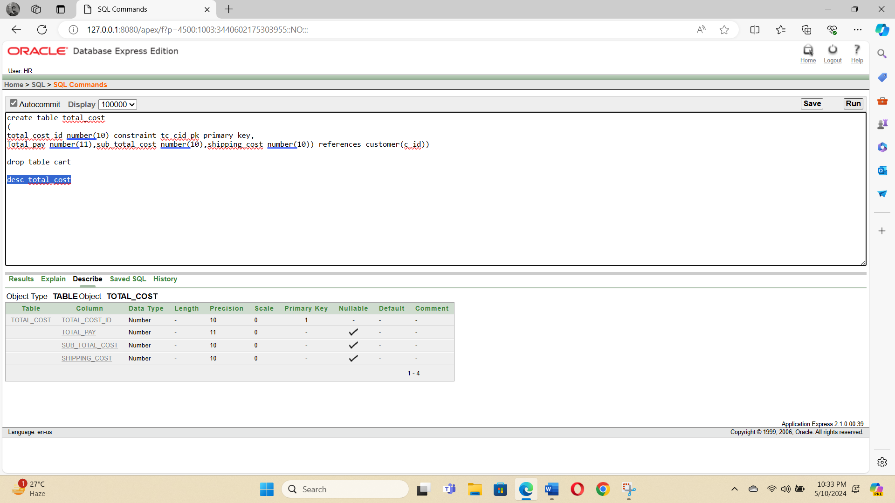

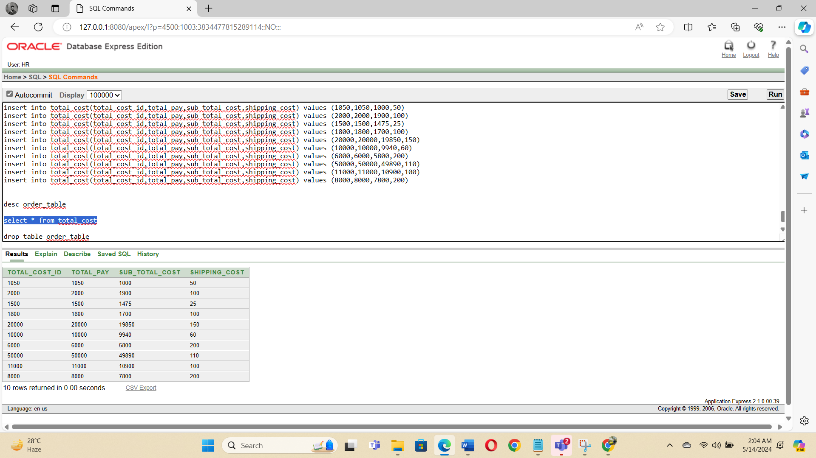

**Query Test in DB**

1. Conditional Statement:

1.select m_name from manager where m_name like '_a%'

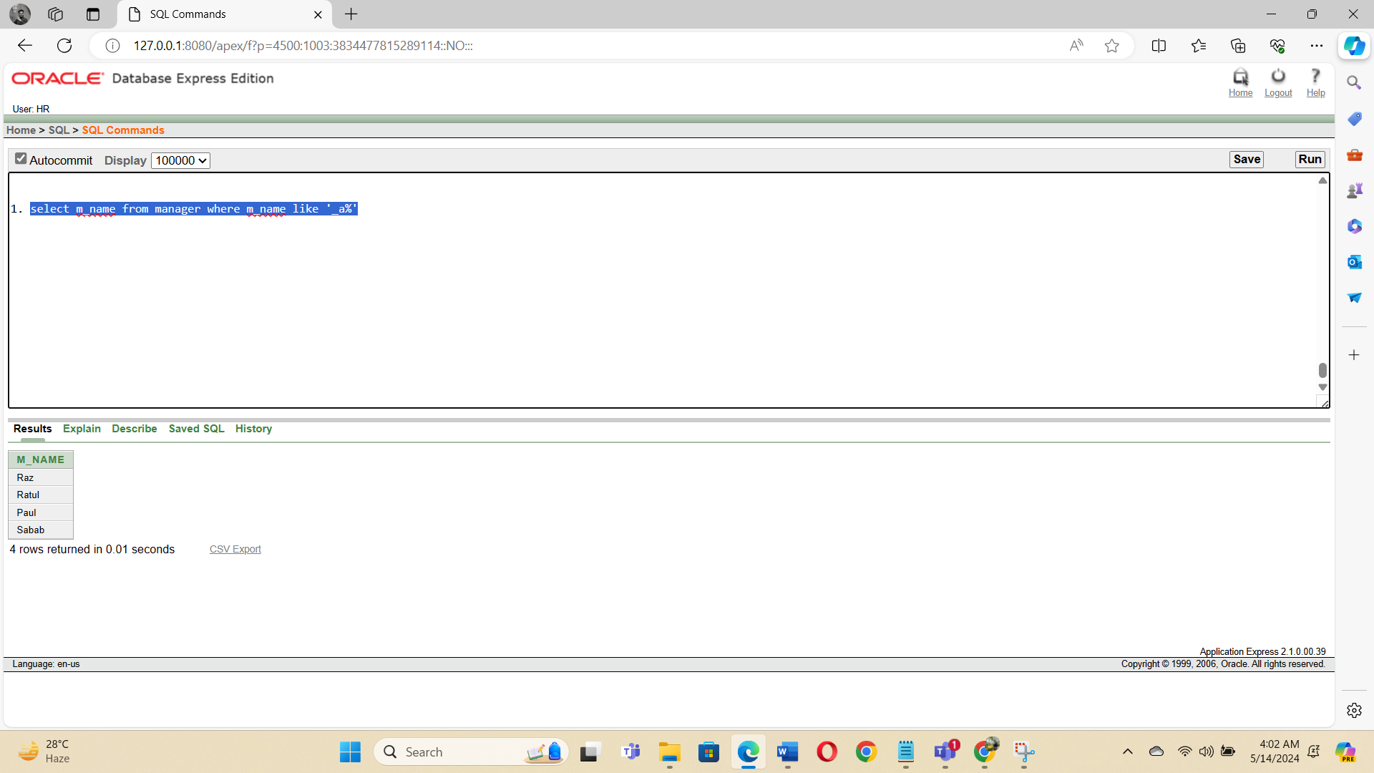

2. sselect * from manager where salary > 1000

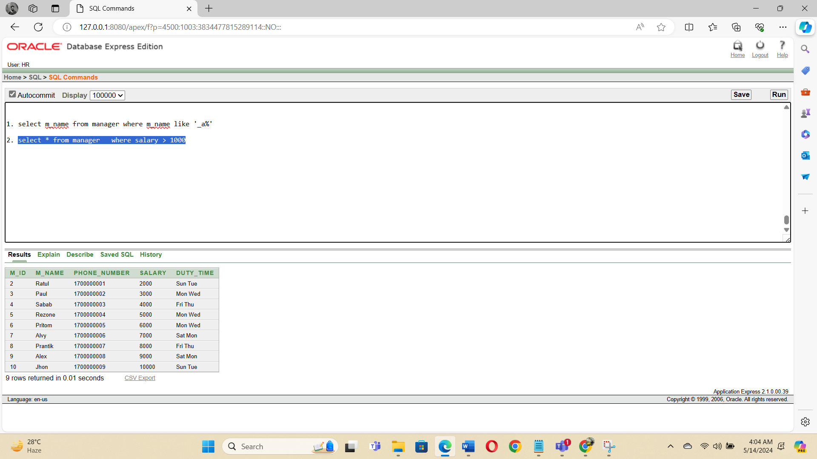

3. select * from customer where c_id = '3010'

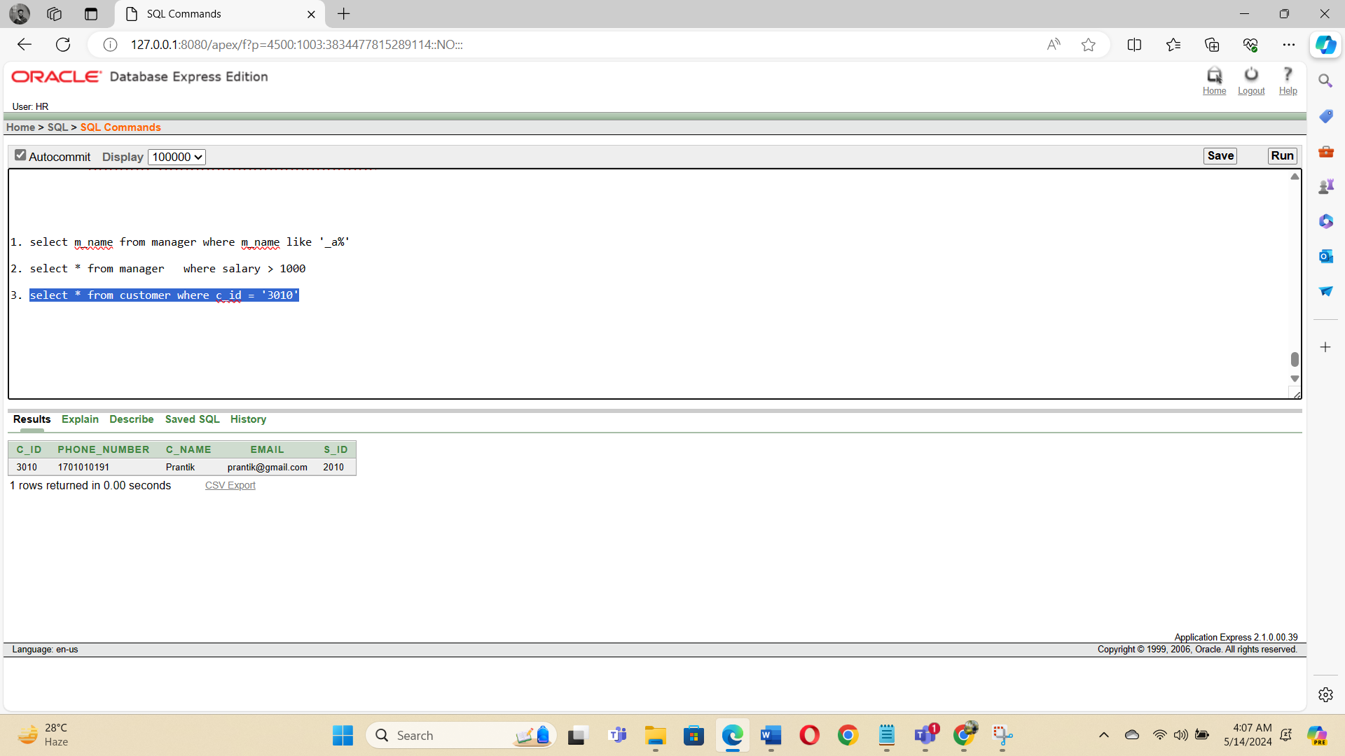

4. select * from gadget where g_name = 'Mouse'

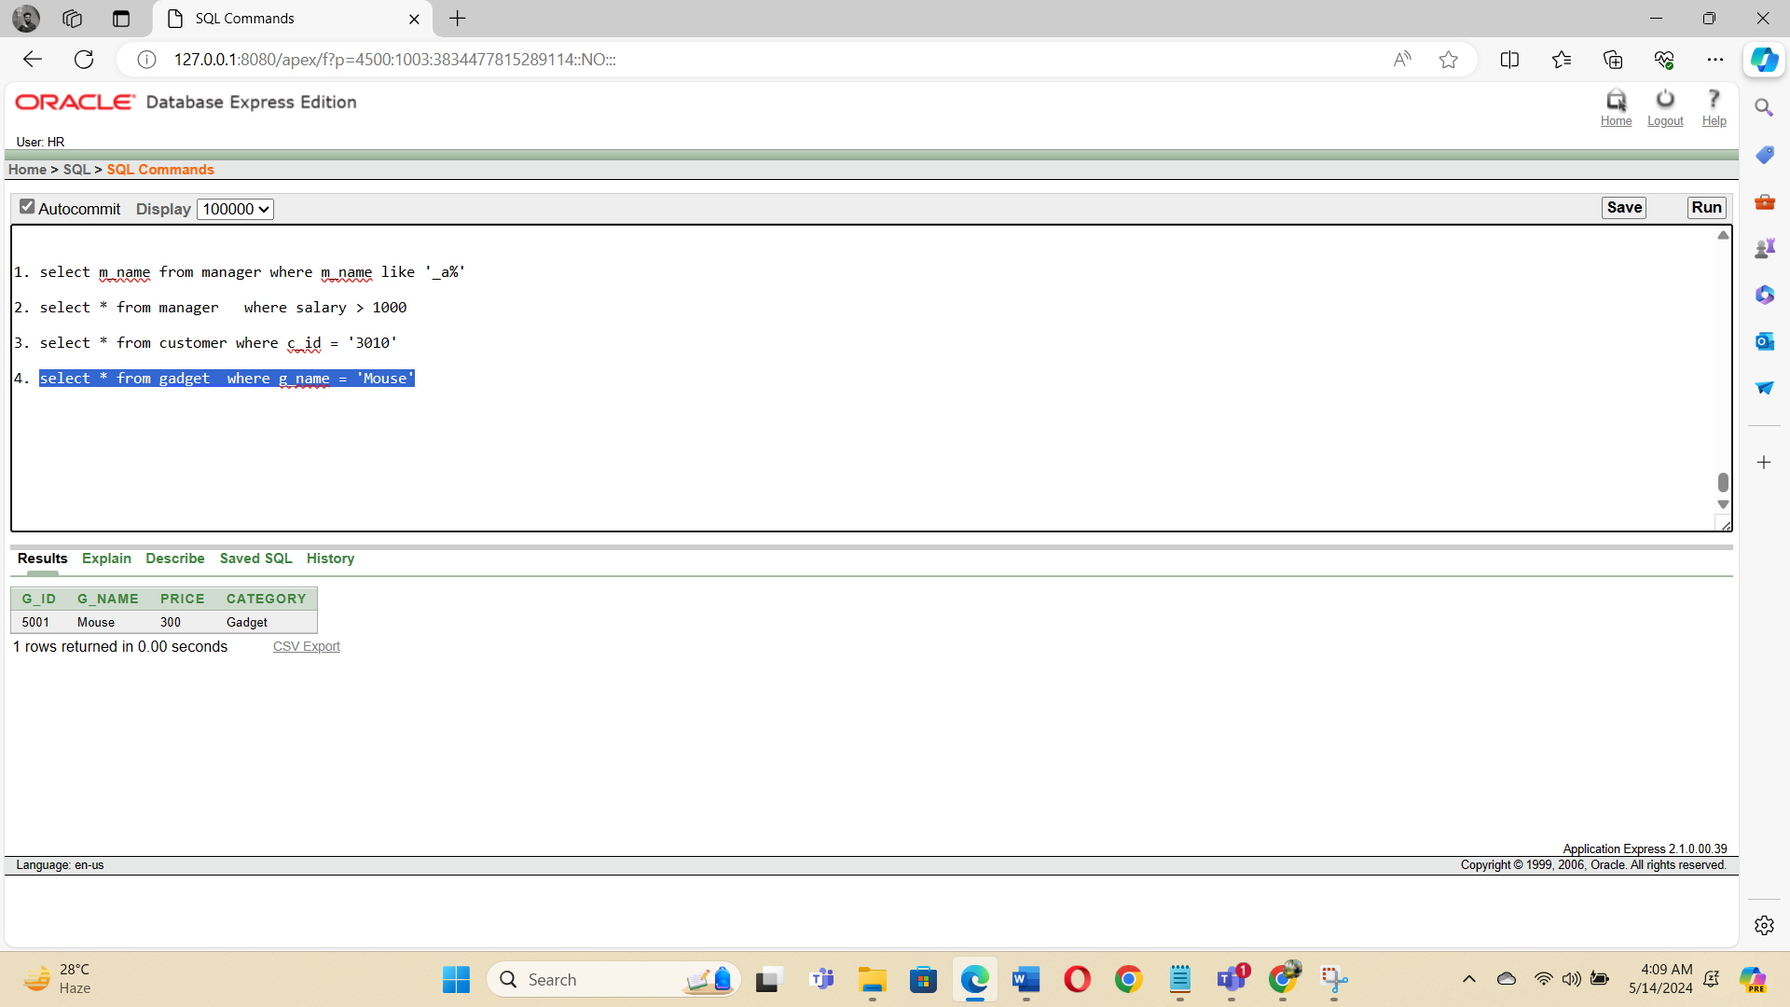

5. select * from cart_table where or_id= 8010

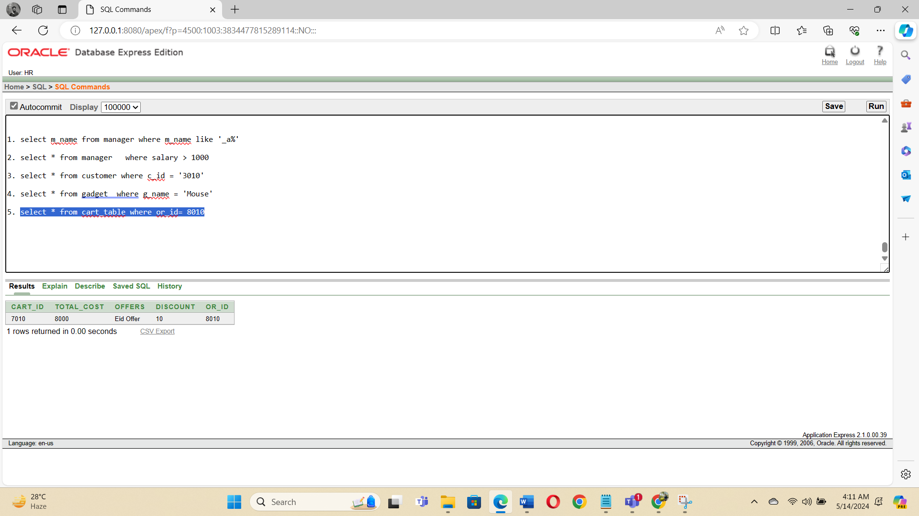

B) Single row function:

1. select m_id,m_name, CONCAT(m_id,m_name) from manager

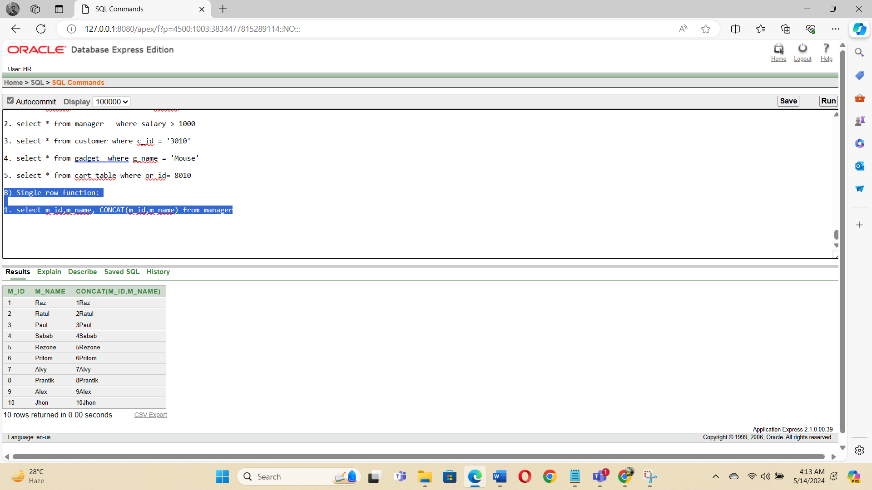

2. select c_id,UPPER(c_name) from customer

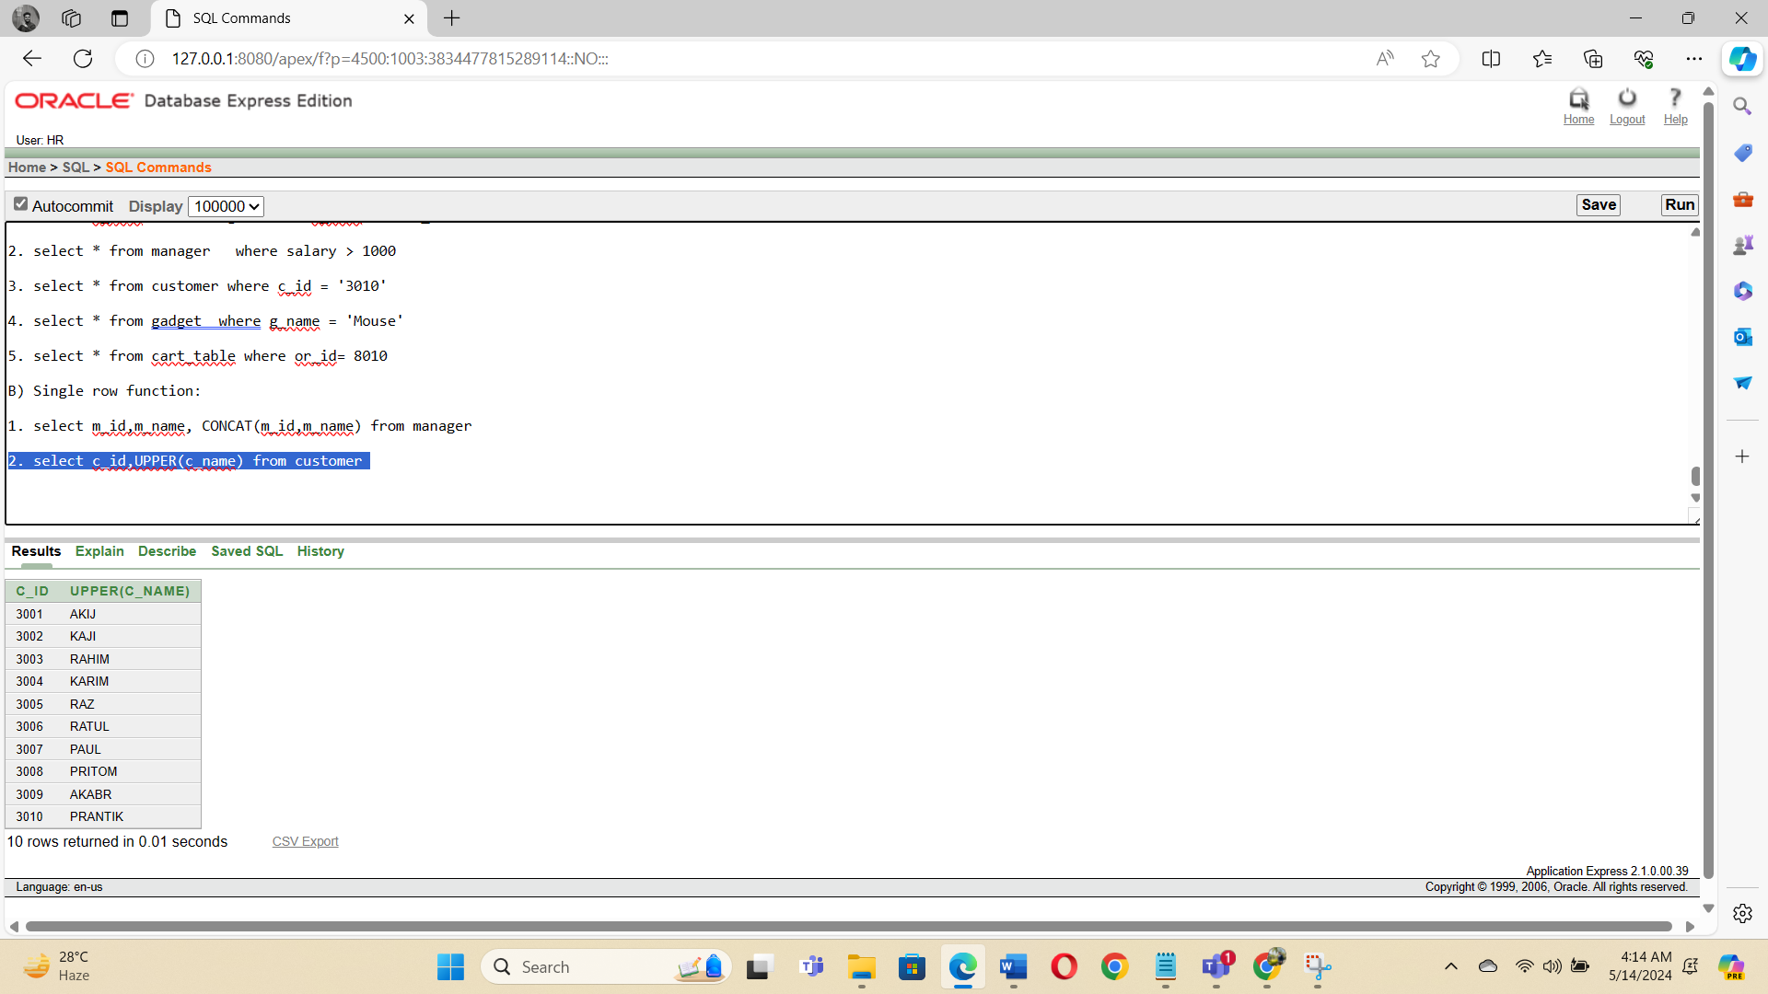

3. select g_id, g_name ,SUBSTR(g_name, 1, 3) as first_three_characters_name from gadget

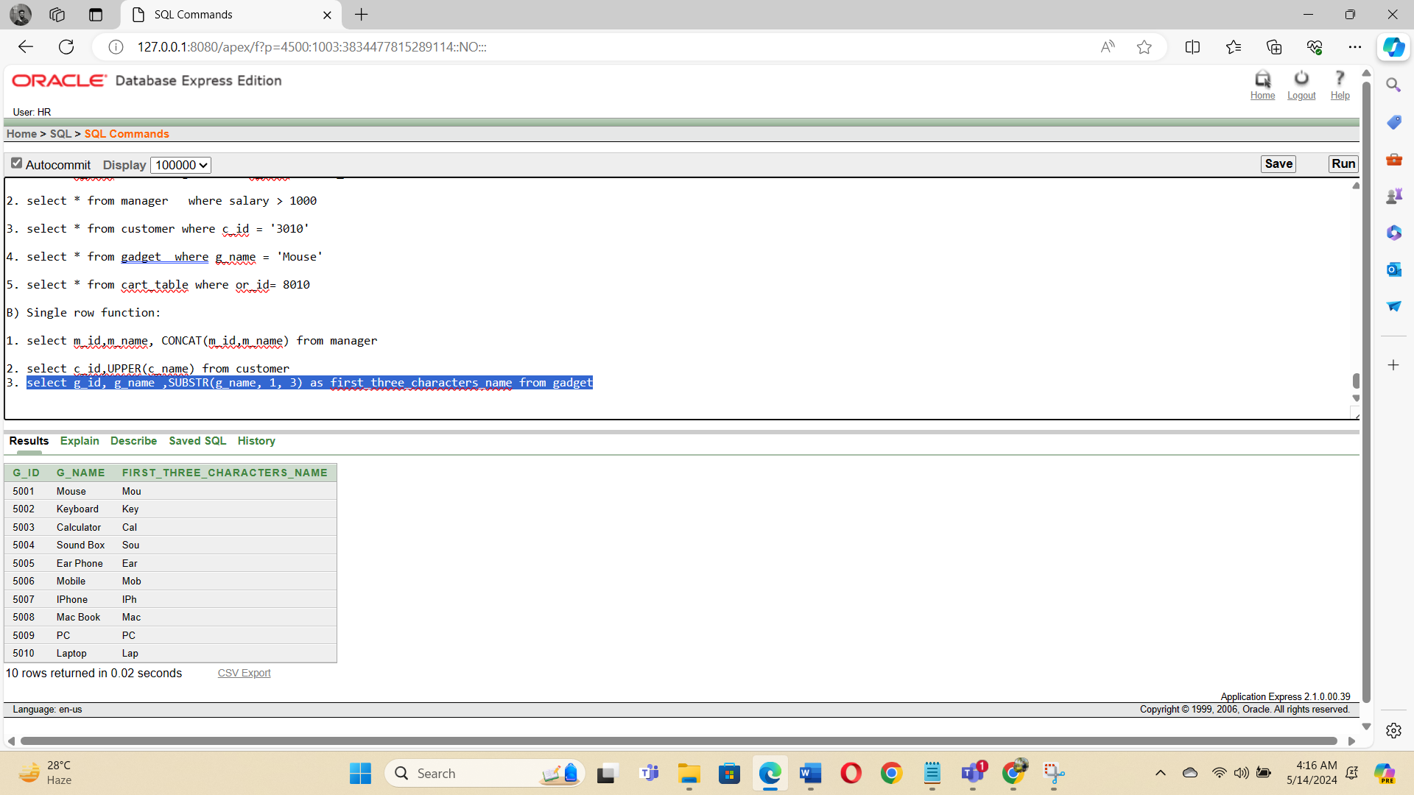

4. select * from customer where c_id between '3001' and '3005'

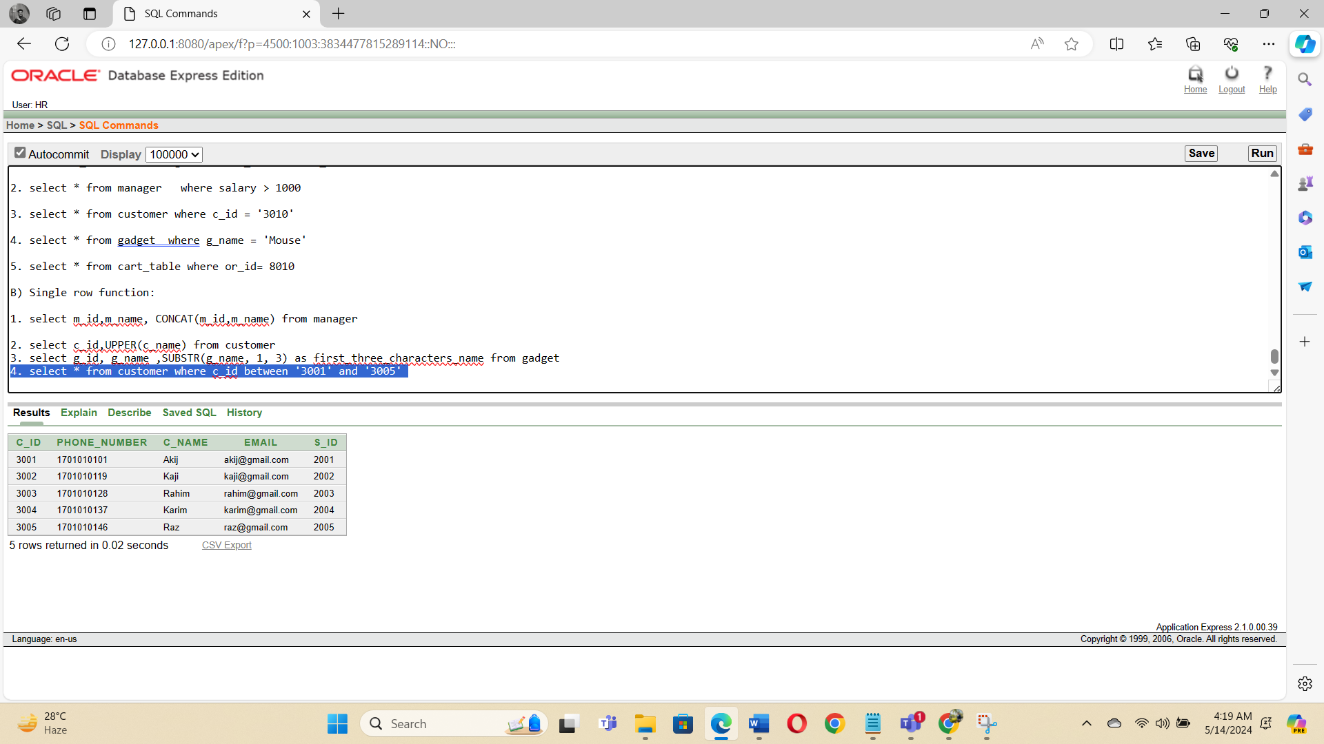

5. select email, LENGTH(email) as email_length from customer

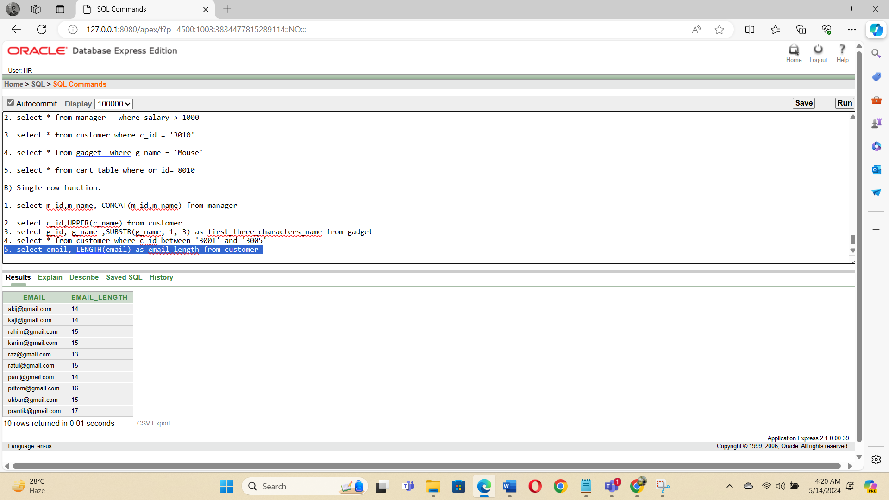

**C) Multiple row function:**

1. select min(salary) from manager

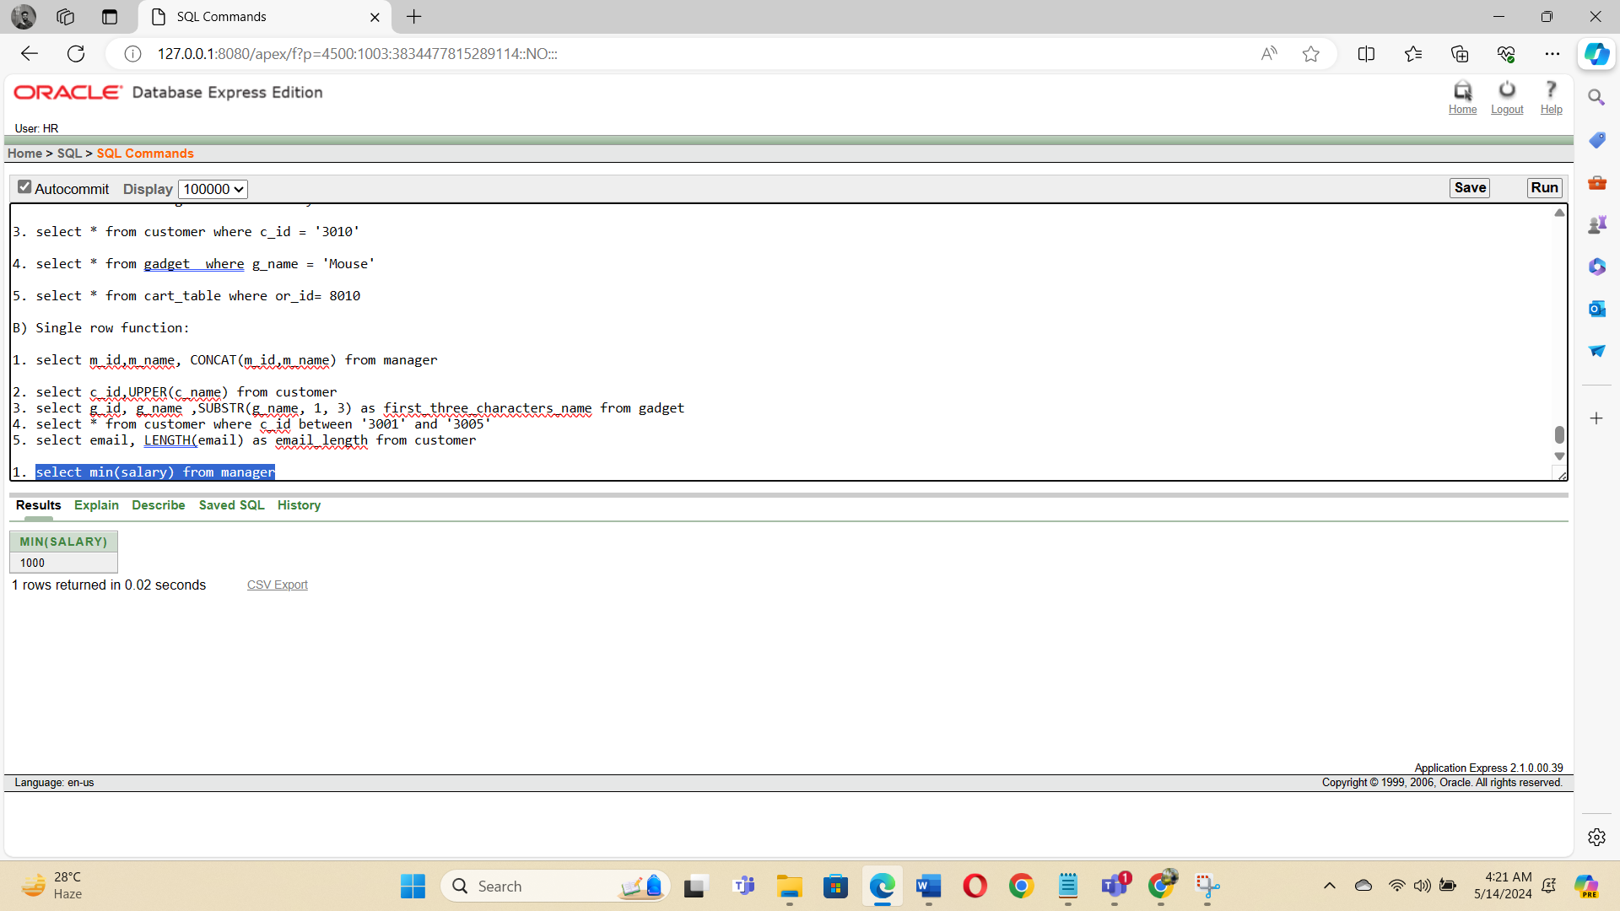

2. select count(s_id) from salesman

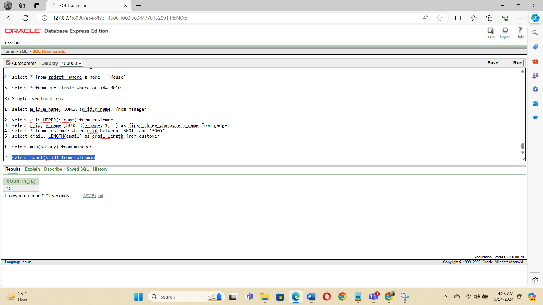

3. select * from product where p_id not in(101,102,103)

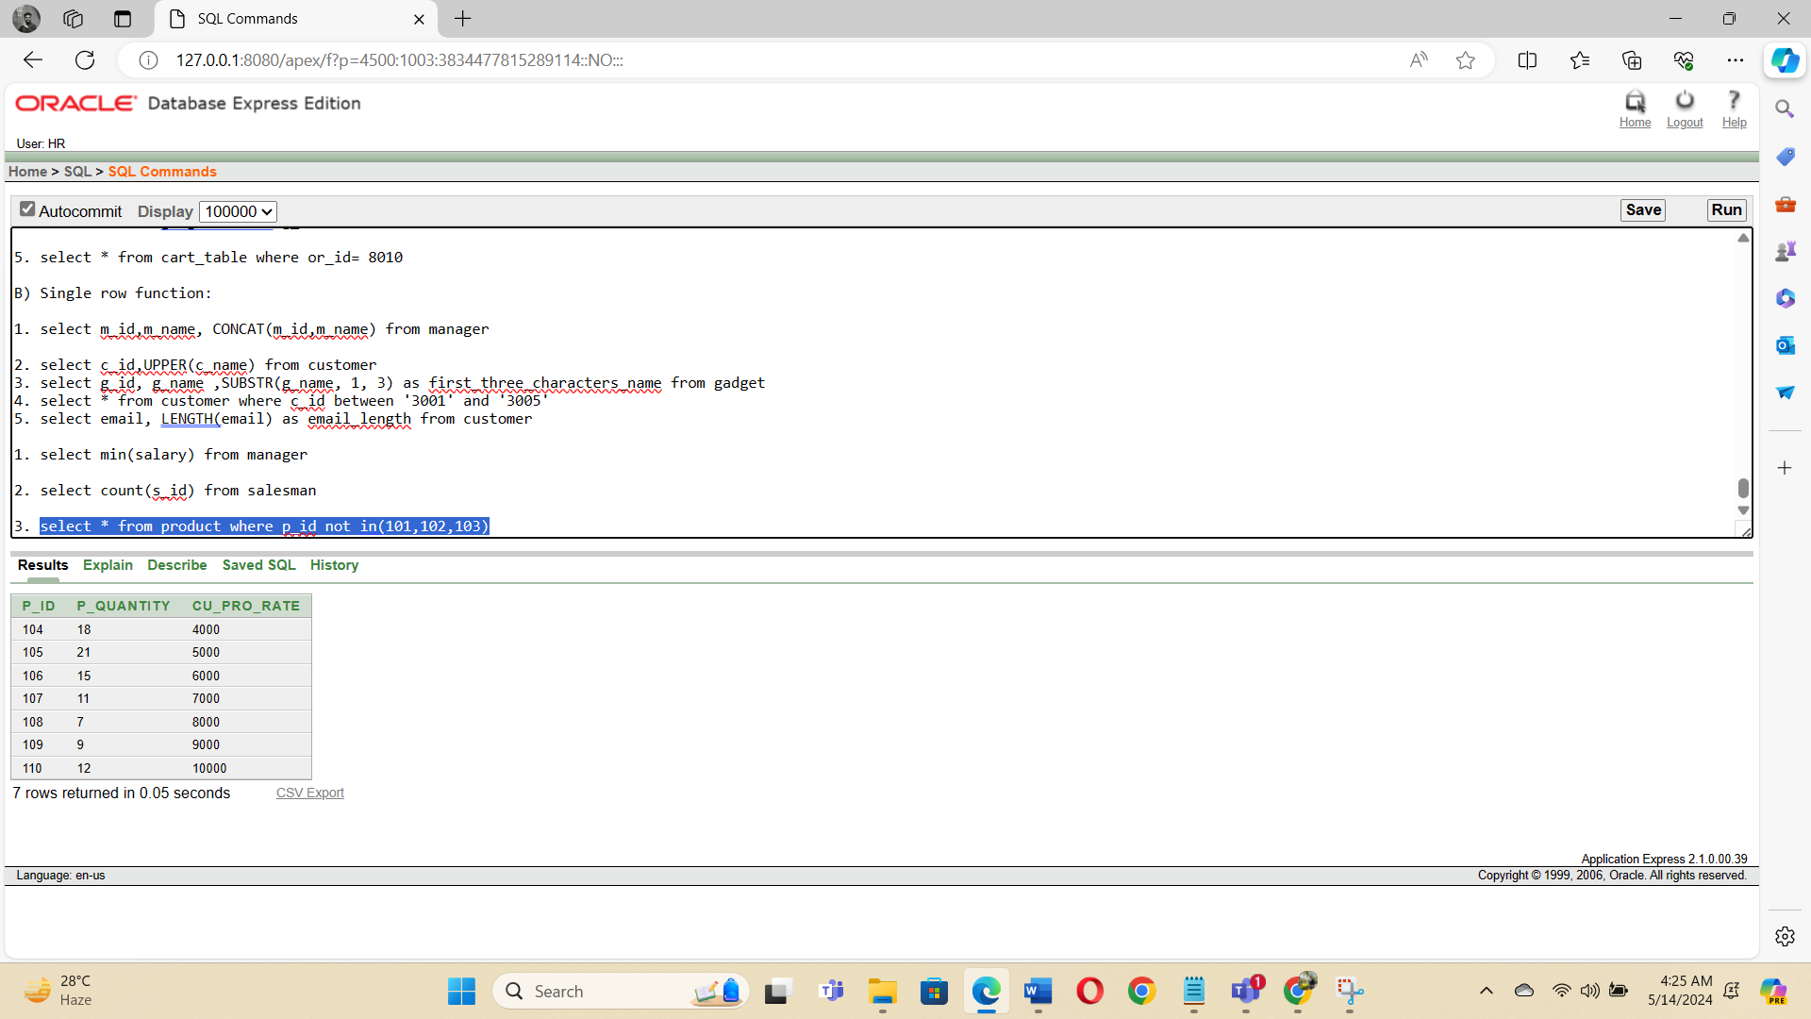

**d) Subquery:**

1. select m_name, m_id from manager where salary > (select salary from manager where m_name='Raz')

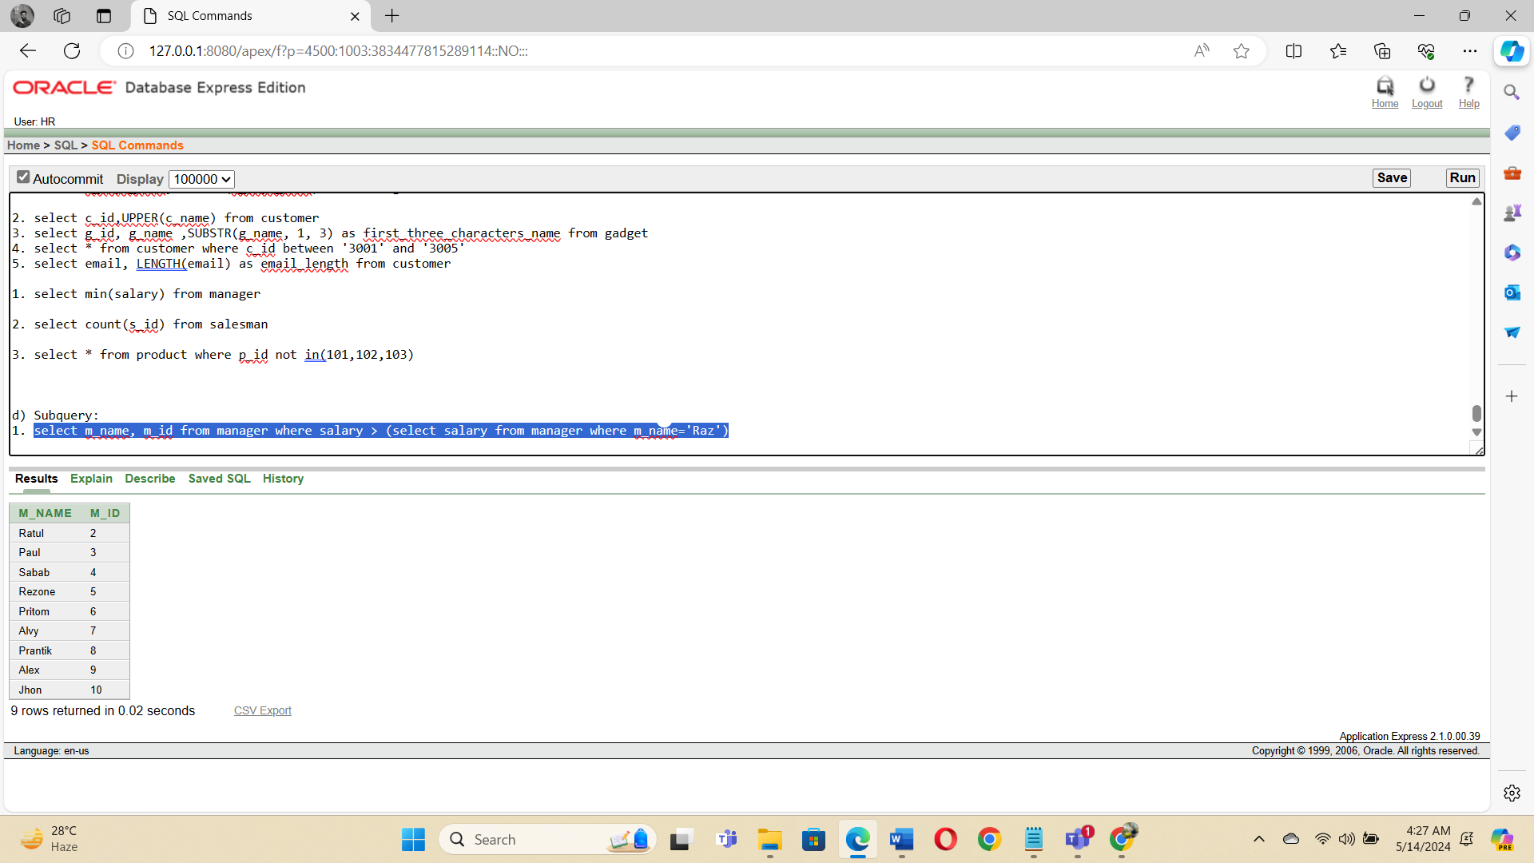

2. select m_name, m_id from manager where duty_time = (select duty_time from manager where m_id=02)

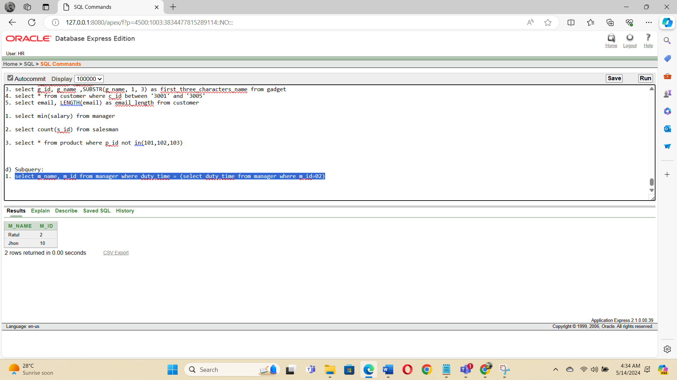

**e)Create View**

SELECT m_id, m_name from Manager WHERE m_name = 'Raz'

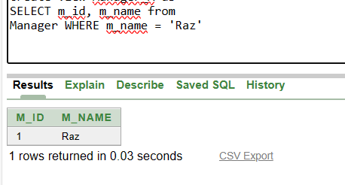

**Relational Algebra:**

1. Display all information from manager those member whose member ID is 02 .

[ ]

Manager

σ

m_id=02

2. Display customer id, email those customer name Karim

[ ]

Customer

σ

c_name = ‘Karim’

π

c_id,email

3. Write a query to display the manager ID, name who id under 09.

[ ]

Manager

σ

m_id < ‘09’

π

m_id,m_name

4. Write a query to display the salesman name and salary whose salary between 100 and 1000

[ ]

salesman

σ

salary betweeb 100 and 1000

π

s_name,salary

5. Display the manager’s maximum and minimum salary

Manager

π

max(salary),min(salary)

6. Write a query to display the Manager’s name, salary where bonus is 10% of their salary.

Manager

π

m_name, salary, salary*0.10 as Bonus

7. Write a query to display the Trainer name where the second letter of their name is a.

[ ]

Manager

σ

M_name like ‘_A%’

π

m_name

8. Display salesman id ,salary and manager id for all salesman.

[ ]

salesman x manager

σ

s.s_id = m.m_id

π

s_id,salary,m_id

9. Display customer id ,phone number and salesman id for all customer.

[ ]

customer x salesman

σ

c.c_id = s.s_id

π

c_id , phone_number , s_id

10. Display the gadget maximum and minimum value.

Gadget

π

max(price) , min(price)

**Conclusion**

In our gadget and gear management system we create many connection between salesman, manager , branch etc. etc. In normalization , we normalized up to 3nf . We tried to incorporate all relatable entity and

store their data in the simplest but efficient manner possible. After complete this project, we are designed a real world scenario and applied the theoretical knowledge in the project . There are some facilities that in sql is case sensitive .